Assignment 1   
Hands-on  
Database Management systems   
(Spring 2018)

***laverty@rmu.edu***

Contents

**Introduction 4**

**Researching Your Answers 4**

**A Little Advice Before you start 5**

**Demonstrating Knowledge and Increased Penalties for Irrelevant Answers 6**

**You Must Submit YOUR Answer in this Original Word Document to Blackboard 6**

**You Must RENAME this Original Word Document to Include your LAST NAME 7**

**NEVER submitted an Assignment as an Email Attachment 7**

**ONLY Submit a FINAL Version of ALL Assignment 7**

**Requests to Clear Previously Assignments for Re-Submission 7**

**Submitting Late Assignments 7**

**Academic Integrity and Plagiarism 8**

**1.0 Using PuTTY to Logon to Linux 9**

**1.1 Download to SQL files to preparing for this Assignment 9**

**1.2 Introduction to Putty 9**

**1.3 Linux SSH Public/Private Key Authentication versus a Password 10**

**1.4 Store the PPK File provided you in either your RMU U: Drive, USB drive, or local drive 11**

**1.5 Initial Putty Configuration and Logon 12**

**1.5.1 Connecting the Putty Saved Session Configuration file to the PPK File 14**

**1.5.2 Change the Keep Alives 15**

**1.5.3 Connect to the mediaweb.rmu.edu Linux Server 16**

**1.5.4 Network error: Software caused connection abort 17**

**1.6 Enter your Linux account 17**

**1.7 Successful Logon 18**

**1.8 No Supported Authentication Methods Available 19**

**1.9 Server unexpectedly closed the network connection 20**

**1.10 Network error: Connection timed out 20**

**1.11 Improving the appearance of the PuTTY window 21**

**1.12 Your Linux Home Directory 23**

**1.13 Assignment Snipping Tool Documentation 24**

**1.13.1 Do not chop off these important snipping tool documentation 24**

**1.13.2 Use of copy and-paste while using Putty. 24**

**1.13.3 Copy and-paste can NOT be used for Assignment documentation. 25**

**1.14 Logout from the Linux Server 25**

**1.15 Restarting a New Session 26**

**2.0 Introduction to Linux and the command line interface (CLI) 27**

**2.1 ls command 28**

**2.2 date, man and who commands 30**

**2.3 Other Linux commands 31**

**3.0 Install WinSCP or other SSH upload utility 33**

**3.1 Use Google to find a WinSCP download site. 33**

**3.2 After left-clicking on the Installation package you be prompted to Save the File. 33**

**3.3 Click on the Run Button to continue 33**

**3.4 Select English and continue the installation using the defaults. 34**

**3.5 Left Click on the Yes button to agree to Import PuTTY sites 34**

**3.6 Editing an Existing WinSCP Site 35**

**3.7 Creating a New Site 35**

**3.8 The WinSCP File Transfer View - The Command View. 36**

**4.0 Using WinSCP 37**

**4.1 Editing, Renaming, Deleting. 37**

**4.2 Uploading (copying) a file from your personal computer to medialab.rmu.edu using WinSCP 38**

**4.2.1 Upload the file create_project.sql to mediaweb.rmu.edu 38**

**4.2.2 Repeat the file transfer process for remaining SQL script files 40**

**4.3 Document the SQL script file transfers using command line Linux 40**

**5.0 SQLPlus and Oracle Authentication and Authoization 42**

**5.1. Use the sqlplus Linux command 42**

**5.2. Review your INFS6240 email for sqlplus and Oracle Logon details 43**

**5.3 Enter to Oracle password provided to you in the email sent to you. 43**

**5.3.1 Linux versus Oracle Authentication 44**

**5.3.2 Linux versus Oracle Authorizations 44**

**5.3.3 SQL code development and Linux Authorization 44**

**5.4 The SQL> Command Prompt 45**

**5.4.1 You MAY execute SQL statements or SQL*Plus commands at the SQL> prompt 45**

**5.4.2 You may NOT directly enter Linux Commands at the SQL> prompt 46**

**5.4.3 SQL*Plus Error Prefixes 46**

**5.4.4 Executing Linux commands at The SQL> prompt 46**

**5.4.5 SQL*Plus clear screen command 47**

**6.0 Executing SQL Script Files 48**

**6.1 SQL*Plus @ (at symbol) 48**

**6.2 SQL Script files 48**

**6.3 Execute and Document your Project Management Database 49**

**6.4 Document using user_all_tables. 51**

**6.5 Documenting your word using the DESCRIBE command 53**

**7.0 Exiting SQL*Plus and Linux 54**

**8.0 Review Questions 55**

**Enter your Name Here 🡺**

# Introduction

**Assignment 1 is organized into two documents: Assignment 1 – Theory and Assignment 1- Hands-on.**

**Assignment 1 – Theory will be allocated 60% of the assignment points**

**Assignment 1 – Hands-on will be allocated 40% of the Assignment points.**

## Researching Your Answers

Most requirements of this assignment will require you to research answers from your text book (**you must read the text book to get some answers**), from the Internet, from a video or any other reasonable source. Many Internet sources, video links, text book and Blackboard presentations are provided in this document to help you START your research.

Assignments are always a great place to read and reference your text book. May students assume that they should start by reading the text book. While this reading the text book is ALWAYS at great idea, the following assignment questions may help you focus on what is important in this course***. One strategy is to review an assignment question for important keywords, e.g., multitasking, Procedure Division, virtualization, etc. Then look for those key words in either 1) your text book "detailed" table of contents in the beginning of the book, or 2) in the index at the end of the book. Some text books have key word glossaries at the end of the chapter or end of the book.***

Every semester the Internet sources, e.g., a Google keyword search, or Internet video, e.g., a YouTube keyword search may be improved. Better students start with research sources provided in this assignment, and then search for improved or updated answers. ***While your objective may be to demonstrate your knowledge to EARN an excellent grade on this assignment, better students are always looking towards the future to impress internship and career recruiters for those interesting and high entry-level salaries.*** Employers don't pay you for a grade in any single class or assignment. Employers will pay you BIG MONEY for demonstrated knowledge or skills. Hopefully, this assignment will prepare you.

A single research source maybe very incomplete or the format or the content may not be appropriate for some required answers. Some students do not READ the text book or review the Blackboard presentations provided to you in Blackboard. Some answers are only available from Blackboard presentations or update documents. When assignment requirements may be only answered by viewing a YouTube video, you will be notified.

You may cut-and-paste answers whenever appropriate. You MUST synthesize your answers to include multiple sources. I would be impressed that you consult a Google image search and paste and appropriate image to supplement your answer.

While I permit cut-and-paste, I do expect you use your own words so that you:

1. Organize the answer

2. Demonstrate that you have read what you have cut-and-pasted

3. Use any means that clearly displays that you have gained knowledge.

## A Little Advice Before you start

There is NO requirement to read each reference link or view each video in detail. Some of the links will have overlapping content. Some links will provide more information than the question requirements, but employers consider these topics to be minimal knowledge of a RMU CIS graduate.

It is recommended to visit each reference link and overview the content. Then read each question and return to each reference link or video as needed. You may supplement your answers with content from your text book by using a question keyword and looking up in the glossary or index in the back of the book. PDF text books can be easily searched for keywords.

It is not required to read your text books before working on this assignment unless specified in a requirement. Text book contents are used to support quiz questions (which contain the answers), which are used on the tests. The reference links and videos are excellent resources.

The topics presented in the course assignments have been highly recommended by two or more employers who recruit RMU CIS students as minimum computer hardware, operating system, and application development knowledge. Employers expect that students should be able to present one or two sentences of the majority of keywords applicable to job requirements in a face-to-face interview.

On the other hand, each assignment is allocated 100 points out of a total of 1000 points. The number of questions or hands-on activity on each assignment varies. Assume that an average assignment has 50 requirement questions. This means that a requirement may be worth 2 points towards your final grade. The bottom line is that missing a few questions will have little effect of your assignment or final grade. Not completing an assignment will generally decrease your final grade by at least a letter grade. Do not waste time on the small problems.

## Demonstrating Knowledge and Increased Penalties for Irrelevant Answers

If you can DEMONSTRATE your knowledge of the topic for the requirement there will be no penalty for your answer. It is not the intention of this assignment to be "not picky". Parital credit will be awarded as appropriate.

If you cut-and-paste and pray that your instructor will not read your inappropriate and irrelevant answer, the question will be penalized by increasing the deduction points beyond the original requirement points. The instructor hates irrelevant cut-and-paste BS, or answers that appears that the student is guessing and hopes the instructor does not read the answer.

***The instructor reserves the right to increase the penalty for any submitted question or assignment that may be construed as "wasting the instructor's time".*** Therefore, a four-point requirement may be penalized as six-points (two additional point penalty for wasting the instructor's time). Sometimes blank answers will earn you’re a high assignment grade than BS answers. For example, a submitted 100-point assignment may be penalized as 125 minus points when your final grade is calculated for any assignment that should have never been submitted in the first place.

## You Must Submit YOUR Answer in this Original Word Document to Blackboard

***This Assignment Word Document will contain hidden markers that may be used to detect plagiarism and provide an audit trail of those who may have modified the Word document.***  Many students in my classes work very hard to complete and learn from their assignments. It is not fair to those students who have professionally demonstrated their knowledge to receive the same grade as those who have plagiarized their assignments

**You MUST answer ALL requirement in this Word document and ONLY THIS Word Document. You MAY NOT use or edit any other word processor, except any version of Microsoft Word.**

**Do not use GOOGLE DOCS or Open Office DOCX files at any time. If you use any other Word Processor you will be assigned ZERO credit.**

**If you do not have a copy of WORD**, you may use VMWARE VIEW (available from the RMU website) to access a virtual lab computer which contains any software needed for this course.

<http://www.rmu.edu/web/cms/departments-offices/administration-services/it/Pages/vmware-view.aspx>

NEVER STORE ANY DOCUMENTS ON THE DESKTOP OF VMWARE VIRTUAL COMPUTER. You will lose your document. It is preferable to store your documents on RMU Drive U: If necessary you can email the document to yourself.

## You Must RENAME this Original Word Document to Include your LAST NAME

**YOU MUST enter your name in the beginning of this document as provided and "Save As" this document using a new name that starts with your LAST NAME, assignment number and semester, e.g., Jones Assignment 1 Summer 2016.docx**

If you do not rename your document your assignment will be penalized by 10%.

## NEVER submitted an Assignment as an Email Attachment

All assignments are to be submitted to the instructor by using the Assignment Link in the Blackboard system. Assignments submitted as an email attachment will NOT be graded. THE INSTRUCTOR NEVER ACCEPTS ANY ASSIGNMENT AS AN EMAIL ATTACHMENT FOR ANY REASON.

## ONLY Submit a FINAL Version of ALL Assignment

Never submit an incomplete assignment for grading. Only submit your final version of ALL assignment documents for grading. You can only submit an Assignment once.

## Requests to Clear Previously Assignments for Re-Submission

If you make an error submitting an assignment you must contact the instructor to clear your previous assignment submission. If you made an error on any assignment you may request that the previous assignment submission be cleared so that you may resubmit the assignment again. Please only submit a completed assignment. Spring 2018

## Submitting Late Assignments

While the assignments have a recommended due date, the instructor does not penalized your assignment grade if you are slightly late. Please do not send the instructor an email if you are going to submit your assignment late. The instructor is flexible and assumes you have a good excuse. But, after you are more than two weeks late the instructor does reserve to penalize the assignment or not accept the assignment if this late submission is unfair to other students enrolled in the course who had completed their assignments on time.

It has been the experience of the instructor that students who are excessively or consistently late asks a friend to provide them a copy of their assignment which will violate the RMU Academic Integrity Policy. (Please carefully read the next section!) ***If a friend asks you for a copy of your assignment "to get an idea what the instructor wants", you are risking a zero assignment grade, an F final grade, or a RMU Academic warning or suspension.***

## Academic Integrity and Plagiarism

When an instructor has possession of an electronic document it is easy to detect plagiarism. Microsoft Word provides a variety of FREE anti-plagiarizing tools. The content of your submitted Assignment WORD document will be COMPARED to each other student who has submitted this assignment in the current class or any previous class as time permits. ***The content of each student's assignment may NOT be copied from any other current or past student enrolled in this class. Each assignment is to be prepared by ONE student. Assignments are NOT a group-prepared assignment.***

Some students may attempt to SAVE AS another student's completed assignment and rename it using their name. Some students may attempt to Cut-and-Paste answers from one student's assignment document to another student's assignment document. But as time permits, the forensic tools used to compare ALL student's assignments with other assignment will often detect anomalies which will provide absolute proof of plagiarism. ***On-ground tests may be used to compare the student’s knowledge to performance on assignments. All acts of plagiarism and forensic data will be submitted the RMU Academic Integrity Board to determine university-wide penalties, such as grade penalties, warnings, suspension, and change of a previous course grade for previous course students. All current and previous students involved in the plagiarism may be affected RMU Academic Integrity Board.***

***If a friend asks you for a copy of your assignment "to get an idea what the instructor wants", you are risking a zero assignment grade, an F final grade, or a RMU Academic warning or suspension. You are responsible to protect your assignment Word Document.***

***You, however, may discuss assignment requirements, provide research assistance, assist other students to debug programs or other hands-on-requirements, tutor students, or provide other advice that may assist the students in acquiring knowledge. But the actual preparation of an individual assignment must have been completely prepared by the student who submitted the assignment. Sections of the assignments may be copied from the internet as per the individual assignment's directions. Please contact the instructor if you need assistance interpreting this RMU Academic Integrity Policy. (Ref.16-1.)***

Many believe that if you a "stupid" enough provide another student, whom may compete with you for a future internship or career, a copy of your assignment, then you deserve the same penalty as the other student. If you are a "real" friend, tutor your friend.

***The instructor reserves the right to require face-to-face hands-on demonstrations or face-to-face tests to provide additional evidence to be submitted to the RMU Academic Integrity Board.***

# 1.0 Using PuTTY to Logon to Linux

## 1.1 Download to SQL files to preparing for this Assignment

**It is important that you download the following files from the Blackboard Assignment Links: create_project.sql, insert_project, create_view_project.sql and select_project.sql. These files contain SQL statements that will create several tables and views, insert sample data and display the sample data.**

**These files will be upload to the course’ Linux server using WinSCP during this assignment.**

**The SQL files will be executed in Oracle to provide tables that will be used in Assignment 2 to introduce SQL DML statements.**

## 1.2 Introduction to Putty

Video - Connect remotely from a Windows Computer to a Linux Computer - <https://www.youtube.com/watch?v=X7-RKtDBGvI>

Video - Tutorial 1 Downloading and Configuring Putty (SoundTraining) - <https://www.youtube.com/watch?v=RhD08kJOTy0>

Video - Connect Remotely from a Windows Computer to a Linux Computer - <https://www.youtube.com/watch?v=X7-RKtDBGvI>

PuTTY is a free SSH, Telnet and Rlogin client for 32/64 bit Windows systems. PuTTY may be used to connect to a remote Linux or UNIX text-based terminal. PuTTY does not support a GUI desktop directly, but can use an X11 forward feature to provide some GUI features.

PuTTY is installed on all RMU Lab computers and VMware View client and HTTP virtual desktops. Putty can be easily installed on your home computer, laptop or mobile device. The previous list of videos will provide examples how to download and install Putty on Windows computer. But, there is a variety of downloads and videos available to install Putty or any other SSH client app on any device by searching Google.

Our Enterprise Oracle version 12c is running under a Linux host computer that is identified by the domain name mediaweb.rmu.edu. Every time one may access a remote host computer across a TCP/IP network, the host computer must be identified by either a unique host name or a unique IP address. In this course the host domain name will be used, similar to the process of using the host domain of google.com. But, ultimately every host domain name must be converted (DNS Lookup) an IP address.

A domain name may identify host computer. A host computer may have many different programs running. Every once in a while I take a break and play Free Cell as I am writing this assignment. To identify and connect a single program that is executing on the remote host, we will enter a port number. When using Putty or WinSCP is connected to a remote host, it is normal to connect to the Secure Shell program of daemon at port 22. Later on in this course we will connect directly to Oracle. At that time we will use a different client and enter port 1521.

For now we are going to configure PuTTY to access remote host media.rmu.edu and port 22. We will then save the PuTTY configuration session data.

Once connected to the Linux host named mediaweb.rmu.edu, we will enter our LINUX user account (sent to you by email) and then authenticate our logon name. Normally one will enter a password. But, in this course we will not use a Linux password. We will use SSH Public key encryption. A private key, which also was sent to you by email as an attachment. DOWNLOAD THE FILE WITH THE *.ppk FILE EXTENSION to your computer. You will need it

Many sites enable access to SSH through their firewalls, but this exposes them to password probing. This is usually an automated process of trying to authenticate with commonly-used username/password pairs. SSH supports public-key authentication and it greatly reduces the risk of remote exploits due to weak credentials. Let’s further explore why you would consider this approach, and how to implement it.

## 1.3 Linux SSH Public/Private Key Authentication versus a Password

Instead of authenticating your Linux account with a password, upon will be required to use SSH Public/Private Key Authentication. A SSH public key is a file stored in Linux user home folder and your SSH Private key will be stored in Putty, or other SSH client. The following email message will distribute your Linux account SSH private key to be installed in Putty.

**Advantages of public-key authentication.**

1. You must possess the private key that matches the public key stored on the server you wish to log into. Without the key, password probing can never succeed, since a remote attacker should never have your private key. If you believe your key has been compromised, generate a new one!

2. Through the use of an SSH authentication agent, you load your key and enter the corresponding passphrase once. Thereafter, the agent handles passing the information to the requesting server. In effect, this means that once you’ve loaded your key, you do not need your passphrase (and depending on your configuration, not even your username) to login. This makes authentication both safer and faster!

**Disadvantages of public-key authentication.**

1. SSH Public key encryption should never be used the root account. However, root account should never be remotely login in anyway. Our SSH server configuration on the mediaweb.rmu.edu has correctly disabled remote access. A root user logon using any account, and then use sudo for all activities that require root privileges.

2. Users have to generate key pairs, and someone has to put the public keys in place on the appropriate servers. However, this can be scripted! This process has been done for you.

## 1.4 Store the PPK File provided you in either your RMU U: Drive, USB drive, or local drive

**1. Start any browser and access your RMU email account.**

**2. Open the email message with the Subject Line similar to the following**

[INFS62401-L1] Student account setup information for XXXXXX, where XXXXX will be your email name as well as your Linux account. The content of email message should appear similar to the following.

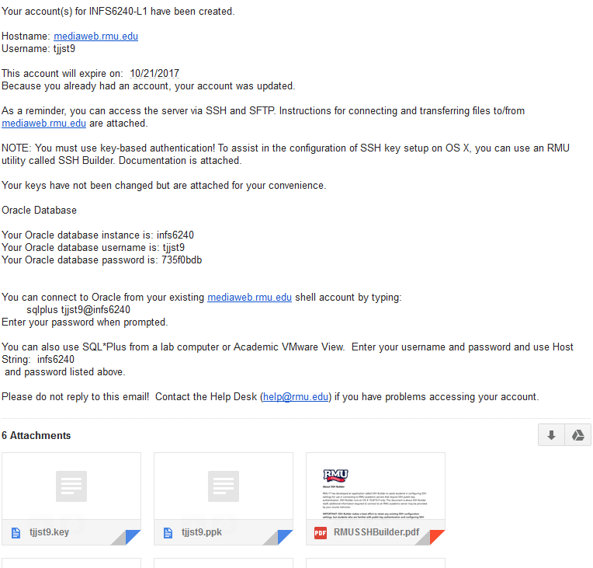

Notice that an email message displays the content of the Public key file. There are two versions of this key file is attached. The first version is a .PEM file which has formatted the private key file for use on a MAC. Since we will only use a Windows client, the .PEM format will not be used in this course. The second versions is a PPK which has formatted the private key file for use on Windows.

**3. Download and Save the PPK key file**

## 1.5 Initial Putty Configuration and Logon

1. **Install Putty or start Putty**. Your RMU IT email has directions for several SSH clients for both the MAC and Windows computers. The following directions apply to using PuTTY. You may install Putty on either your personal Windows or MAC laptop. While you access PuTTY on either ay RMU lab computer or RMU VMware View, it is highly recommended that you install it on your personal laptop. If you use PuTTY on a RMU lab or VMware View computer you must repeat the following installation steps each time you access the Linux server.

2. **Enter mediaweb.rmu.edu as the Linux host name of the Linux computer that contains Oracle.** Enter **mediaweb.rmu.edu** in the Host Name (or IP Address) dialog box.

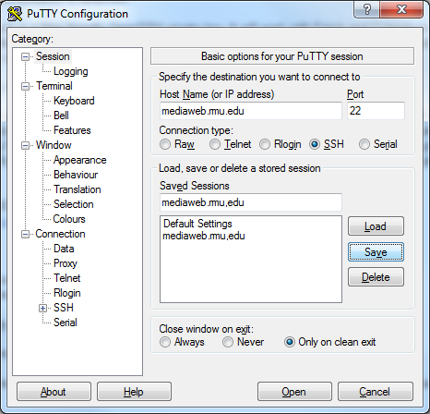

3. **Ensure that the port is set to Port 22 and button SSH option button has been selected under Connection Type.** SSH stands for secured shell and will provide both encryption and remote connection services. Normally, a SSH daemon or server listens to port 22, but port 22 is not required for the SSH daemon. Some believe that using a non-standard SSH port improves security, but if a SSH server is listening under any other port, the nmap command will find it.

4. **Enter a Saved Sessions name**. In the following example the session name of mediaweb.rmu.edu was used. However, you can use any name you want as a Saved Session. A Saved Session is store all of the PuTTy configuration information in an arbitrarily name Putty Saved Session file. This means that you can save and reuse this configuration information. Click on the **Save button** to create a new PuTTY Session file. To open or reuse the session configuration click on the button name **Load.**

Remember, this Putty Session configuration will automatically be erased once you logoff form the RMU lab computer or VMware View, and you must repeat the following step.



### 1.5.1 Connecting the Putty Saved Session Configuration file to the PPK File

In the Category menu located in the left-pane of Putty, click on **Connection**, click on **SSH** and select **Auth**

Click on the Browse button and navigate to the folder where you saved the *.ppk file.

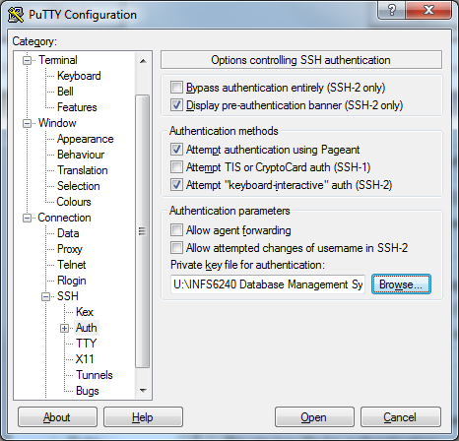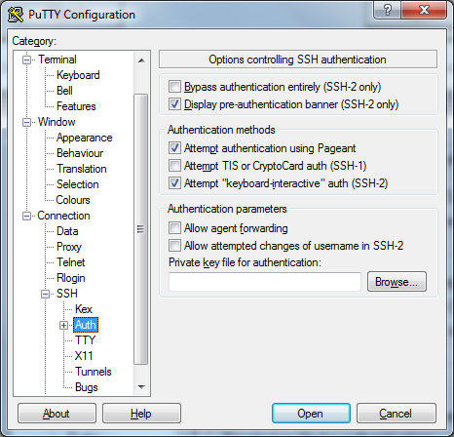

### 1.5.2 Change the Keep Alives

While one could open a Putty session and connect to the mediawbe.rmu.edu Linux virtual machine, I would highly recommend one additional Putty configuration change. Select **Connection** on the Putty Configuration Category Menu.

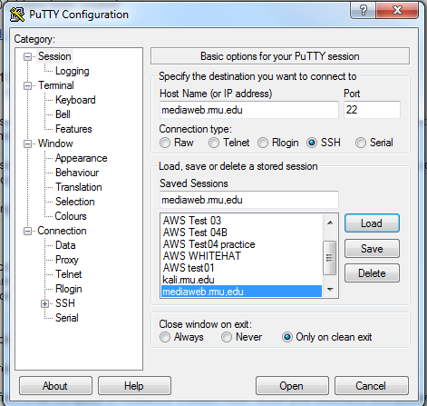

By default most Fedora servers will automatically log you out if the server sees no activity from you within 30 seconds. If you decide to search Google for an answer with a delay of 30 seconds or more, Putty will disconnect your session.

PuTTY can automatically send KeepAlive packets every few minutes to keep your current session active. Using 120 seconds is a popular value.

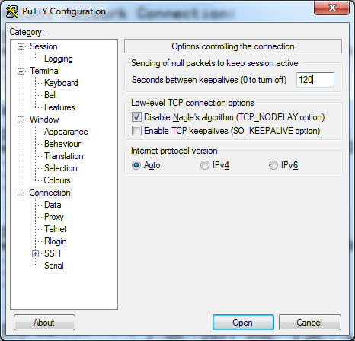

Position the cursor on the dialog box name Seconds between keepalives (0 to turn off)



### 1.5.3 Connect to the mediaweb.rmu.edu Linux Server

**The Putty Keep alives do not work until you successfully logon. You have 30 seconds to logon**

Select the Session Category and click on the Open Button



### 1.5.4 Network error: Software caused connection abort

**If you cannot connect to the mediaweb.rmu.edu Linux server to attempt any type of LINUX logon, you may see the following error message.**

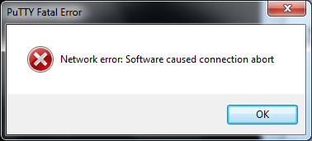

There are many reasons why you may not be able to connect to your Kali Linux server.

1. Incorrect host name or IP address.

2. Incorrect port or SSH selection

3. Network down. Trying pinging your host name provided by your PPK email

## 1.6 Enter your Linux account



After a successful network connection, the Kali Linux server will prompt you for a Logon name.

Your Linux account was provided in your email. It was case sensitive – ALL lower case letters should be used. The Putty Keep alives do not work until you successfully logon. **You have 30 seconds to logon.**

**If the Linux sever has been configured for SSH Key authentication you will not be prompted for a password**

## 1.7 Successful Logon

After you first connect to the Linux Kali Server you should NEVER see the Putty Security Alert dialog box. You may have seen this dialog before, but when your use SSH Public key authentication your will never see this message. Why? The Linux server wants to provide you’re the SSH encryption key and use password authentication.

**The First Time**

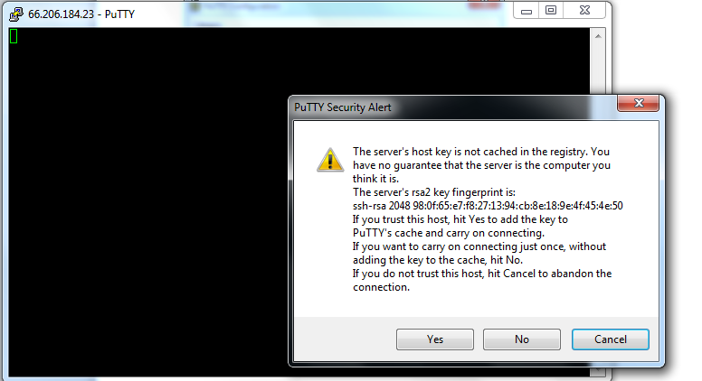

**After a successful logon you will see the Linux command prompt, where you may enter any Linux command, or to access SQL*Plus to start Oracle**

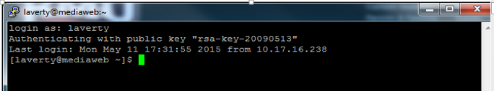

## 1.8 No Supported Authentication Methods Available

**But, I successfully logon before?**

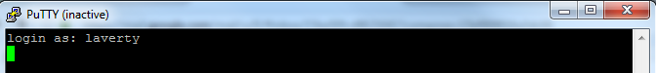

But, now you get the following Putty Fatal Error Message

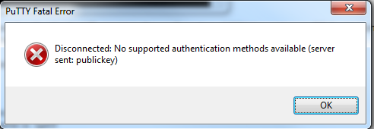

However, we must repeat steps to Connect Putty to the PPK File each time we restart PuTTY using an RMU lab computer or VMware view. Before you click on OPEN recheck Connecting Putty to the PPK File again. If the **Private key file for authentication text box is blank, click on the Browse button to reconnect to it BEFORE you open the connection.**

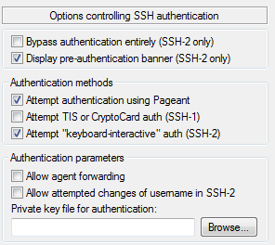

## 1.9 Server unexpectedly closed the network connection

You didn't type your logon name in 30 seconds.

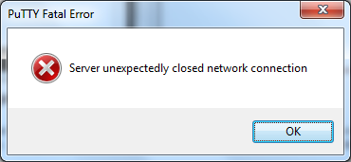

## 1.10 Network error: Connection timed out

You didn't set your Keep Alives or failed to reconfigured Putty the next time you used a RMU Lab computer or VMware

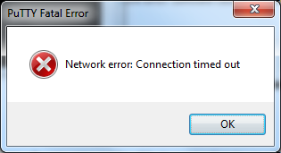

## 1.11 Improving the appearance of the PuTTY window

The following image is very difficult to read due to the white characters on a black background. **If the instructor cannot read your documentation, then they cannot grade your assignment.**



You can change the Putty configuration setting either BEFORE your open a connection or during the session. To change the configuration settings during the session, right-click on the Putty Title Bar. On the menu select Change Settings. Can you read this????

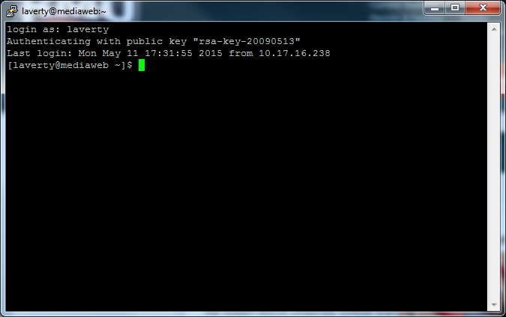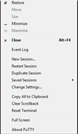

**Some of the changes in the Putty Settings that you do are:**

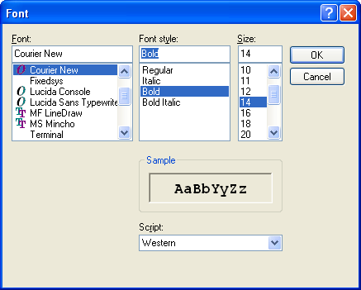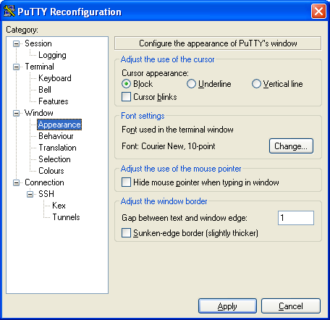1) **Change the point size (or font) under Window/Appearance**. Click CHANGE under Font Settings. A point size of 14 that is bolded is easier to read, but you may get word wrap problems. Clicking on OK only affects the current session.

2) **Change your foreground (font) and background colors under Windows/Colours**. Select each color to adjust one-by-one and select MODIFY. I am going to select a white background with a black font colors. Clicking on OK only affects the current session.

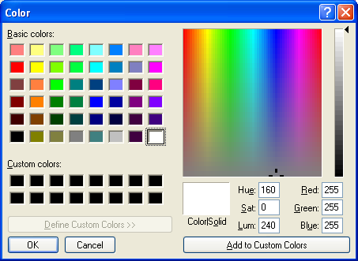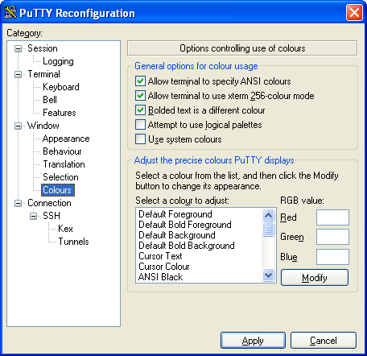

**Click on the Apply Button to change the current session. But, even you save these settings these changes in your Putty Configuration file, they will not be available the next time you use the RMU Lab Computer or RMU VMWare View.**

After these Putty Configuration changes your screen images will look similar to the following.

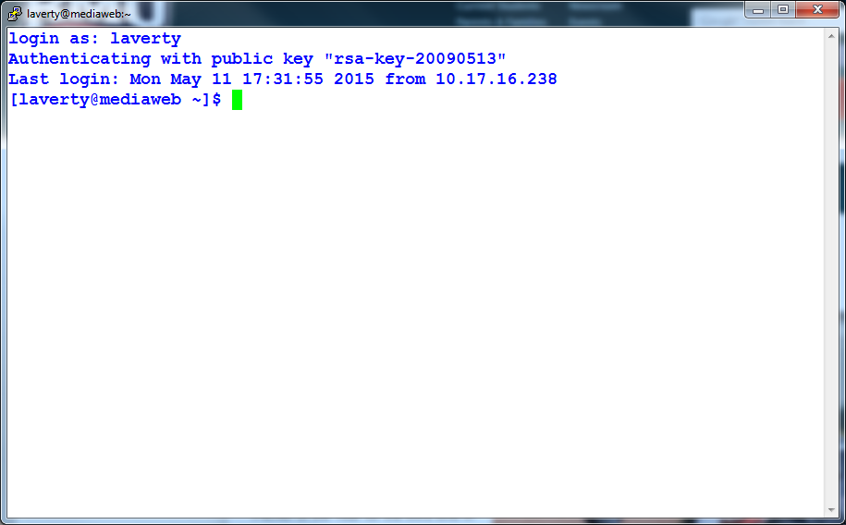ls

## 1.12 Your Linux Home Directory

**A personal Linux subdirectory or folder (called your home directory) will be provided on mediaweb.rmu.edu so that you may store your SQL scripts.**

If you type the Linux **pwd** command, Linux will display the name of the current directory. After you successfully authenticate to Linux your current directory is automatically set to your home directory. The name of my home directory is **/home/laverty**

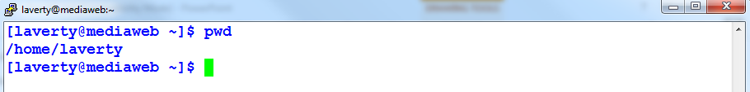

**Notice that Linux directories use a forward slash, e.g.,** /**, while Windows directories use a forward slash, e.g., \.**

**Using a Snipping tool document your current and home directory below using the Linux pwd command**

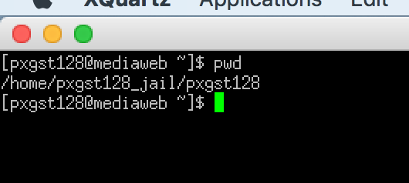

## 1.13 Assignment Snipping Tool Documentation

**Every time you are required to and snipping tool you are required to include you Putty banner document and Linux prompt which includes your Linux account.**

**After each execution of a Linux command type the clear command to erase the Putty Screen.**



### 1.13.1 Do not chop off these important snipping tool documentation

**Do not chop off these important documentation features, else you will receive no credit**

Use a Snipping tool to copy a screen image of your current session or assignment requirement. In above examples, the GUI dialog boxes are clearly displayed as a graphic. **The text displayed in this snipping tool documentation and PuTTY Terminal Windows cannot be edited.**

### 1.13.2 Use of copy and-paste while using Putty.

Often in a PuTTY session you will find text on your terminal screen which you want to type in again. Like most other terminal emulators, PuTTY allows you to copy and paste the text rather than having to type it again. Also, copy and paste uses the Windows clipboard, so that you can paste (for example) URLs into a web browser, or paste from a word processor or spreadsheet into your terminal session. Text-based document

PuTTY's copy and paste works entirely with the mouse. In order to copy text to the clipboard, you just click the left mouse button in the terminal window, and drag to select text. When you let go of the button, the text is automatically copied to the clipboard. You do not need to press Ctrl-C or Ctrl-Ins; in fact, if you do press Ctrl-C, PuTTY will send a Ctrl-C character down your session to the server where it will probably cause a process to be interrupted.

Pasting is done using the right button (or the middle mouse button, if you have a three-button mouse and have set it up. (Pressing Shift-Ins, or selecting `Paste' from the Ctrl+right-click context menu, have the same effect.) When you click the right mouse button, PuTTY will read whatever is in the Windows clipboard and paste it into your session, exactly as if it had been typed at the keyboard. (Therefore, be careful of pasting formatted text into an editor that does automatic indenting; you may find that the spaces pasted from the clipboard plus the spaces added by the editor add up to too many spaces and ruin the formatting. There is nothing PuTTY can do about this.)

If you double-click the left mouse button, PuTTY will select a whole word. If you double-click, hold down the second click, and drag the mouse, PuTTY will select a sequence of whole words. If you triple-click, or triple-click and drag, then PuTTY will select a whole line or sequence of lines.

If you want to select a rectangular region instead of selecting to the end of each line, you can do this by holding down Alt when you make your selection.

If you have a middle mouse button, then you can use it to adjust an existing selection if you selected something slightly wrong. (If you have configured the middle mouse button to paste, then the right mouse button does this instead.) Click the button on the screen, and you can pick up the nearest end of the selection and drag it to somewhere else.

It's possible for the server to ask to handle mouse clicks in the PuTTY window itself. If this happens, the mouse pointer will turn into an arrow, and using the mouse to copy and paste will only work if you hold down Shift.

### 1.13.3 Copy and-paste can NOT be used for Assignment documentation.

Your will be provide examples to make your Putty window documentation appear professional. After making your documentation appear professional you are REQUIRED to use the snipping tool for final; assignment documentation.

**At the Linux command prompt, e.g., [laverty@mediaweb ~]$, prompt you cannot execute SQL commands. You must start the Oracle shell to execute SQL commands. The instructions to start SQLPlus will be presented latter.**

## 1.14 Logout from the Linux Server

Type **exit** to logout of mediaweb.rmu.edu Linux server

When you have finished your session, you should log out by typing the server's own logout command. This might vary between servers; if in doubt, try **exit or logout**, or consult a manual or your system administrator. When the server processes your logout command, the PuTTY window should close itself automatically.

You can close a PuTTY session using the Close button in the window border, but this might confuse the server - a bit like hanging up a telephone unexpectedly in the middle of a conversation. We recommend that you do not do this unless the server has stopped responding to you and you cannot close the window any other way.

The remaining documentation details the PuTTY Main menu (which will control an active session), the Session Configuration dialog box (which will control the start and stop of sessions) and various Logging Options. Most important concepts have already been presented.

## 1.15 Restarting a New Session

Once Putty has been configured and the configuration has been saved it is easy to re-logon to the Linux server. Simply select the correct configure file, click on the Load button, and then click on the Open button. Since Linux is multiuser you may open a connection several times, e.g., have two, three or more Putty sessions for the rmuxxxx account.

**For this assignment, you may use videos or help links for almost any version of Linux.**

# 2.0 Introduction to Linux and the command line interface (CLI)

Linux does support a mouse and GUI Windows-like user interface line. This course will provide students with some experience using Linux and the Oracle text-based interface called SQLPlus. But, from the beginning one must understand he important differences between the Linux operating system and the Oracle DBMS as following examples will switch between two set of commands, i.e., Linux commands and SQLPlus SQL commands.

Review the following Linux command prompt, e.g., [laverty@mediaweb ~]$ Inside the square braces is you user account and host name, followed by the tilda ~ which represents your home directory, logon default directory. The $ at the end of the command prompt indicates that Linux is ready for to enter a Linux command. NOT an SQL statement.



At the Linux command prompt you can perform any operating system operation that you could perform in Windows (and much more). You view file stored in a folder or subdirectory like Windows Explorer. You can open folders, or change a directory. You can edit files similar to using Windows Notepad.

**At the [laverty@mediaweb ~]$ prompt you may execute most Linux/UNIX commands, e.g., ls, cat, pwd, cp, mv, rm, vi, pico, etc.**

Shortly you will be required to upload SQL scripts from your personal computer to be executed. Oracle cannot manage, open, save or create files. This is why we need Linux. Later in the course we will use Oracle’s SQL Developer to create, edit and save files on your local computer operating system. This SQL Developer will temporarily transmit the SQL script file to Oracle for execution. For now, we will experiment with Linux.

The rules for using Linux commands and file names are:

* **ALL LINUX COMMANDS AND FILE NAMES ARE CASE-SENSITIVE.**
* **MOST LINUX COMMANDS AND OPTIONS ARE WRITTEN IN LOWER-CASE LETTERS. VERY FEW LINUX COMMAND OPTIONS MAYBE UPPER CASE - MEMORIZE THE EXCEPTIONS**
* **ALL LINUX COMMANDS ARE FOLLOWED BY AT LEAST ONE SPACE**

## 2.1 ls command

Type: **ls** and press **Enter** to view the contents of your current directory. In this example, the ls command displays a file or subdirectory named public.html.

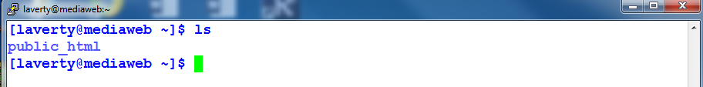

Almost all Linux commands will be lower-case.

Type: **LS** and press **Enter to execute. You should get an error message because you use capital letters**

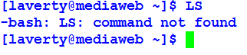

The following requirements will give you a little practice using simple Linux commands.

* **It is required to document BOTH the Putty header and the Linux command prompt which lists your user account. If you cannot document your user account the assignment requirement is NOT acceptable.**
* **When the requirements specify "Document Your Results" You must provide an image using a snipping. You may provide extra documentation images or snippits to document your knowledge at any time.**
* **When a requirement requires an explanation, ensure that the answer is clear and complete.**
* **You must include your name in this document.**

Video - How to Get Help in Linux: Linux Server (SoundTraining) - <https://www.youtube.com/watch?v=EvrFqu7YYUE&list=PLC85E59A343173010&index=3>

Using the presentations "Linux File and Directory Commands" and "Linux Directory Structure"; found under the Linux PPT folder and the following links answer the following questions.

Video - Terminal Commands in Fedora Part 1 - <http://www.youtube.com/user/lecturesnippets#p/u/109/v4u0ZCFbjaI>

Video - Terminal Commands in Fedora Part 2 - <http://www.youtube.com/user/lecturesnippets#p/u/108/2GCQnkywVqo>

Video - Terminal Commands in Fedora Part 3 -

<http://www.youtube.com/user/lecturesnippets#p/u/107/mlvDnqfnPqg>

Video - Terminal Commands in Fedora Part 4 - <http://www.youtube.com/watch?v=mGM2GvT3ebU&feature=related>

Video - Intro to the Linux Terminal Part 3: Text editing with Nano and Vi / Vim - <http://www.youtube.com/watch?v=-WfG_sUz2A8&feature=mfu_in_order&list=UL>

* **REMEMBER ALL LINUX COMMANDS AND FILE NAMES ARE CASE-SENSITIVE.**
* **MOST LINUX COMMANDS AND OPTIONS ARE WRITTEN IN LOWER-CASE LETTERS. VERY FEW LINUX COMMAND OPTIONS MAYBE UPPER CASE - MEMORIZE THE EXCEPTIONS**
* **ALL LINUX COMMANDS ARE FOLLOWED BY AT LEAST ONE SPACE**

## 2.2 date, man and who commands

1. Use PuTTY to logon to the mediaweb.rmu.edu server.

2. At the Linux command prompt, type: **date** and press **Enter** to view the current date and time. **Using a snipping tool** **Document Your Results below.**

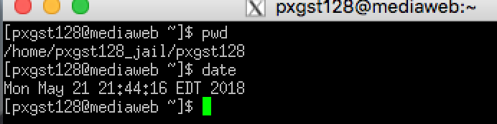

Since your Putty screen may get full the Linux command **clear** (lower case letters please) you clear Linux screen and place the cursor at the top of the Putty window.

Now type **Date** and press **Enter.** **Using a snipping tool** **document your results below.**

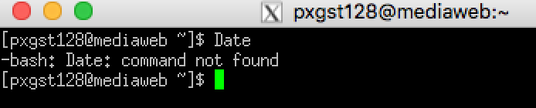

Why did you receive an error message? Can you tell which shell gave you the error message? **Using a snipping tool** **document your results below.**

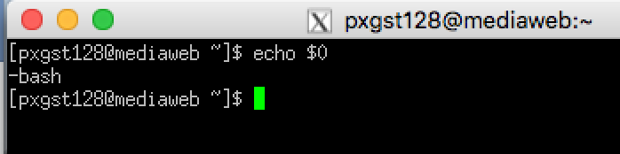

**$0 gives the current shell**

Reading Man Pages - <http://www.linuxcommand.org/reading_man_pages.php>

Using man to get help in Linux and UNIX - <http://www.bleepingcomputer.com/tutorials/using-man-to-get-help-in-linux-and-unix/>

Video - Linux "man" command - <https://www.youtube.com/watch?v=iF_XtCHSmL8>

What is function of the Linux man command? Your answer is 🡺

**A man page shows the command’s syntax, options, and related files and commands.**

3. At the Linux command prompt, type **who** and press **Enter** to view the users logged on to the system and on which terminal there are using? **Using a snipping tool** **document your results below.**

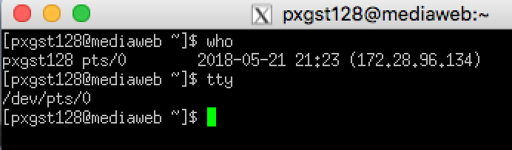

If you enter the Linux command ***man who*** what information will be displayed?

**Document Your Results**

NAME

who - show who is logged on

SYNOPSIS

who [OPTION]... [ FILE | ARG1 ARG2 ]

DESCRIPTION

Print information about users who are currently logged in.

-a, --all

same as -b -d --login -p -r -t -T -u

-b, --boot

time of last system boot

-d, --dead

print dead processes

-H, --heading

print line of column headings

-l, --login

print system login processes

--lookup

attempt to canonicalize hostnames via DNS

-m only hostname and user associated with stdin

-p, --process

print active processes spawned by init

-q, --count

all login names and number of users logged on

-r, --runlevel

print current runlevel

-s, --short

print only name, line, and time (default)

-t, --time

print last system clock change

-T, -w, --mesg

add user’s message status as +, - or ?

-u, --users

list users logged in

--message

same as -T

--writable

same as -T

--help display this help and exit

--version

output version information and exit

If FILE is not specified, use /var/run/utmp. /var/log/wtmp as FILE is common. If ARG1 ARG2 given, -m presumed: ‘am i’ or ‘mom likes’ are usual.

AUTHOR

Written by Joseph Arceneaux, David MacKenzie, and Michael Stone.

REPORTING BUGS

Report who bugs to bug-coreutils@gnu.org

GNU coreutils home page: <http://www.gnu.org/software/coreutils/>

General help using GNU software: <http://www.gnu.org/gethelp/>

Report who translation bugs to <http://translationproject.org/team/>

COPYRIGHT

Copyright © 2010 Free Software Foundation, Inc. License GPLv3+: GNU GPL version 3 or later <http://gnu.org/licenses/gpl.html>.

This is free software: you are free to change and redistribute it. There is NO WARRANTY, to the extent permitted by law.

SEE ALSO

The full documentation for who is maintained as a Texinfo manual. If the info and who programs are properly installed at your site, the command

info coreutils 'who invocation'

should give you access to the complete manual.

GNU coreutils 8.4 March 2017 WHO(1)

* **REMEMBER ALL LINUX COMMANDS AND FILE NAMES ARE CASE-SENSITIVE.**
* **MOST LINUX COMMANDS AND OPTIONS ARE WRITTEN IN LOWER-CASE LETTERS. VERY FEW LINUX COMMAND OPTIONS MAYBE UPPER CASE - MEMORIZE THE EXCEPTIONS**
* **ALL LINUX COMMANDS ARE FOLLOWED BY AT LEAST ONE SPACE**

## 2.3 Other Linux commands

50 Most Frequently Used UNIX / Linux Commands (With Examples) - http://www.thegeekstuff.com/2010/11/50-linux-commands/?utm_source=feedburner

4. Describe the function or purpose the following Linux command, then execute the command and provide a snipping tool image of the results using the following table. It is recommended to use the man command to provide documentation of the command. **Using a snipping tool** **document your results below.**

|  |  |  |
| --- | --- | --- |
| **Linux Command** | ***Purpose*** | ***Snipping tool Image of results*** |
| **clear** | **Clear the terminal screen** | **../../Desktop/Screen%20Shot%202018-05-21%20at%2010.07.41%20PM.png**  **../../Desktop/Screen%20Shot%202018-05-21%20at%2010.08.36%20PM.png** |
| **who** | **Displays who is logged on** | **../../Desktop/Screen%20Shot%202018-05-21%20at%2010.09.23%20PM.png** |
| **ls** | **List directory content** | **../../Desktop/Screen%20Shot%202018-05-21%20at%2010.11.07%20PM.png** |
| **w** | **Show who is logged on and what they are doing** | **../../Desktop/Screen%20Shot%202018-05-21%20at%2010.12.40%20PM.png** |
| **whoami** | **Print effective userid** | **../../Desktop/Screen%20Shot%202018-05-21%20at%2010.15.05%20PM.png** |
| **touch file1** | **Create new file called file1** | **../../Desktop/Screen%20Shot%202018-05-21%20at%2010.18.14%20PM.png** |
| **reset** | **Terminal initialization** | **../../Desktop/Screen%20Shot%202018-05-22%20at%209.28.47%20AM.png** |
| **id** | **Print real and effective user and group ids** | **../../Desktop/Screen%20Shot%202018-05-22%20at%209.31.43%20AM.png** |
| **date** | **Print or set the sytem date and time** | **../../Desktop/Screen%20Shot%202018-05-22%20at%209.32.54%20AM.png** |
| **cal** | **Displays a calender** | **../../Desktop/Screen%20Shot%202018-05-22%20at%209.34.06%20AM.png** |
| **ls –l** | **Displays directories and files** | **../../Desktop/Screen%20Shot%202018-05-22%20at%209.36.10%20AM.png** |
| **ifconfig** | **Config a network interface** | **../../Desktop/Screen%20Shot%202018-05-22%20at%209.37.13%20AM.png** |
| **uname** | **Print system information** | **../../Desktop/Screen%20Shot%202018-05-22%20at%209.39.09%20AM.png** |
| **uname -s** |  | **../../Desktop/Screen%20Shot%202018-05-22%20at%209.40.03%20AM.png** |
| **lscpu** | **Dispays information about the cpu architecture** | **../../Desktop/Screen%20Shot%202018-05-22%20at%209.40.56%20AM.png** |
| **pwd** | **Print name of current working directory** | **../../Desktop/Screen%20Shot%202018-05-22%20at%209.42.03%20AM.png** |
| **cat /etc/passwd** | **Concatenate files and print on the standard output** |  |

# 3.0 Install WinSCP or other SSH upload utility

## 3.1 Use Google to find a WinSCP download site.

You may find the web page confusing to understand. Find the area on the web page that lists the Installation package.



## 3.2 After left-clicking on the Installation package you be prompted to Save the File.

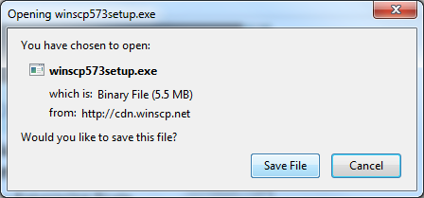

## 3.3 Click on the Run Button to continue

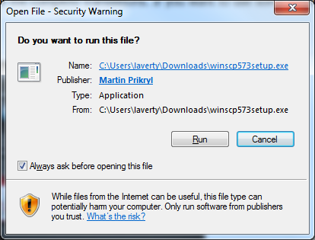

## 3.4 Select English and continue the installation using the defaults.

## 3.5 Left Click on the Yes button to agree to Import PuTTY sites

Later in the WinSCP installation process you will be prompted to transfer Putty’s Session Configuration files to WinSCP.

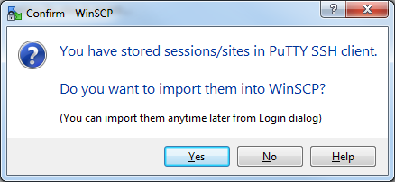

Check the box for any Putty configuration session file (which WinSCP call sites) that you want to transfer. Make sure that you check the box Import cached host keys for checked sites so that you do not have to repeat the *.ppk import process again.

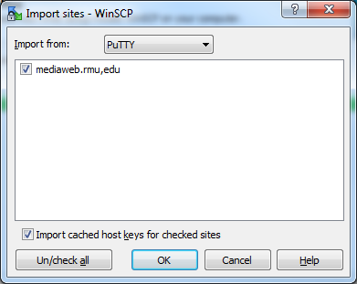

## 3.6 Editing an Existing WinSCP Site

When you start WinSCP you will encounter the Login -WinSCP window. WinSCP store3.7 its configuration information in a site file, which is similar to PuTTY’s session configuration file. If had elected to import the PuTTY sites, you will see the **mediaweb.rmu,edu** site already displayed. However, you cannot directly use this configuration as is. Since you may not have stored the User name in the Putty configuration file, you cannot be authenticated since the User name text box will be blank. To correct this problem **enter the correct User name** before login or preferably click on the **Edit** button, enter the User name and click on Save.

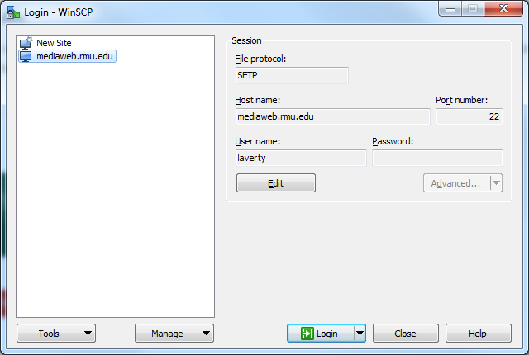

## 3.7 Creating a New Site

To enter a new site, or new configuration file, Click on New Site. Enter a meaningful site name. Make sure that the Port Number is set to 22 and the selected File protocol is SFTP or SCP. The only configuration change to enter is to import the *.ppk. The directions import your private key file are similar to Putty. Locate the correct window. 1) Click on Edit button. 2) Click on Advanced and select the "Advanced" option. 3) On the Advanced Site Settings window select SHH and Authentication in the right panel. 4) Browse to locate your *.ppk file and then select the file. 5) Click on the OK button to exit and then Click on the Save button

## 3.8 The WinSCP File Transfer View - The Command View.

There are two WinSCP File Transfer Views: The **Commander View** and the Windows **Explorer View**. The default view is the Command View, but you may change view by selecting **Options** on the top pull down menu, then select **Preferences,** then **Environment** and, finally select **Interface.** No matter which view you prefer the file transfer procedure is the same.

Select the mediaweb.rmu.edu site and WinSCP Command view will appear similar to the following.

Full Path Name

s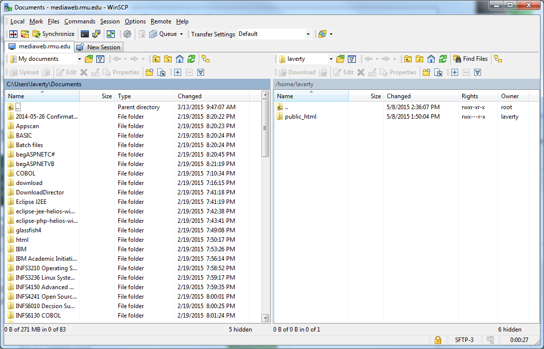

When starting WinSCP, the folders and files of your Home directory of your personal computer are displayed in the LEFT panel. The folders and files of your Home directory of Linux remote host computer are displayed in the RIGHT panel.

# 4.0 Using WinSCP

## 4.1 Editing, Renaming, Deleting.

If you double left-click on any file a pop-up select menu will permit you to edit, rename delete, or transfer a file.

At this point there are very few files on the Linux directory named /home/laverty. Notice that Windows separate folders with a black slash (\), e.g., C:\Users\laverty\Documents, and Linux separates a directory with a forward slash (/), e.g., /home/Laverty

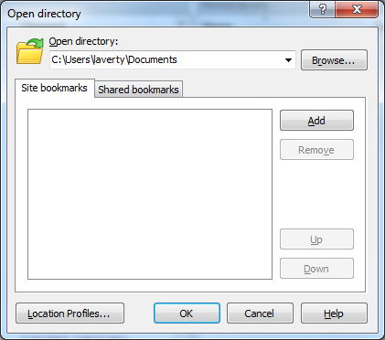

You can easily change local directories by either clicking on the up-arrow icon or double left-click on a folder similar to Windows. Or you double left-click on the pathname to open the Open Directory Dialog box and then Browse to select the desired drive or folder name.

## 4.2 Uploading (copying) a file from your personal computer to medialab.rmu.edu using WinSCP

### 4.2.1 Upload the file create_project.sql to mediaweb.rmu.edu

.

**Step 1.** **Select the file to be transferred.** Select (left-click) the file in the left panel to be uploaded. Left-click on **create_project.sql.** The create_project.sql file is a text file, which may be viewed or edited using Notepad, contains DDL SQL statements, e.g., multiple CREATE TABLE statements, to create the storage structure of a project management database. You are not required to use Notepad at this point, but the following example will display this file. For now you will practice with database that the following SQL scripts will create. Later you will be required to code your personal DDL SQL statements.

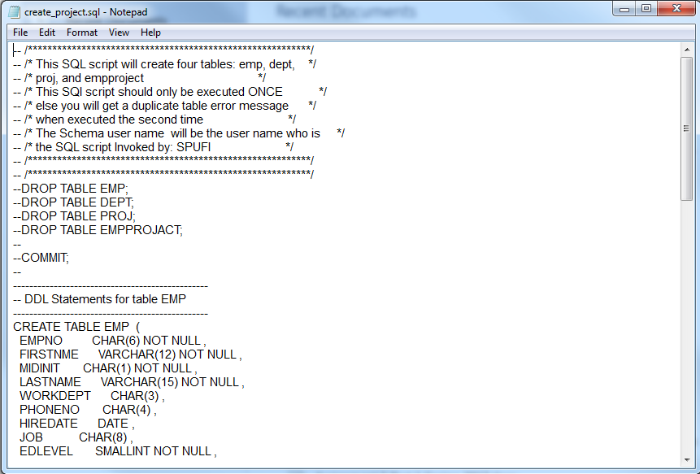

Note: The file extension of SQL is not required as the .DOCX file extension is required for Word documents. However, we will be transferring the pre-coded SQL to a Linux system. In Linux all file names and Oracle names are case sensitive be default.

Normally, when SQL is coded for Oracle on a Linux operating system it is recommended to use lower-case. However, older Oracle DBMS on a z/OS mainframe system where often coded using all upper-case letters. Unlike Linux, Oracle does not distinguish between upper and lower-case letters. Whatever you choose to code your file names or Oracle names, it is recommended to BE CONSISTENT!

**Step 2.** **Start the File transfer or Upload process**. Press the **F5 key** to upload or simply **left-click and drag the file** to your right-panel (the medialab.rmu.edu directory

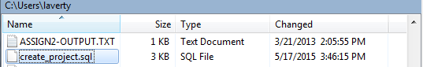

**Step 3.** **Confirm the destination in the Upload Dialog box.** The destination of file transfer will be your Linux home directory. The following example displays the destination as /home/laverty. Your destination directory should be /home/xxxxx, where xxxxx will be your Liniux logon account. Click on **OK** button to continue the upload file transfer, or click on Cancel button to select a different destination directory.

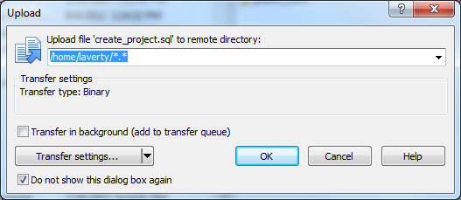

**Step 4.** **File Transfer confirmation.** After the file has been successfully transferred, your right-side Linux pane should appear to to following /home/laverty example.



4.2.2 Repeat the file transfer process for remaining SQL script files:

**Now transfer insert_project,sql, create_view_project.sql, and select_project.sql** files

When finished you should something similar to the following

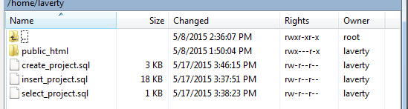

Switch from WinSCP to PuTTY. If you need to re-logon to Linux follow the directions in Requirement 1. At the Linux command prompt type the Linux command **ls** and press the Enter key to execute. You should see something similar to the following.

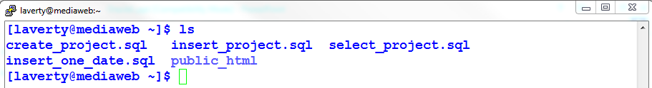

## 4.3 Document the SQL script file transfers using command line Linux

4.3.1 Type and execute the Linux command ***ls***

**Using a snipping tool** **document your results below. Make sure your Putty banner is displayed.**

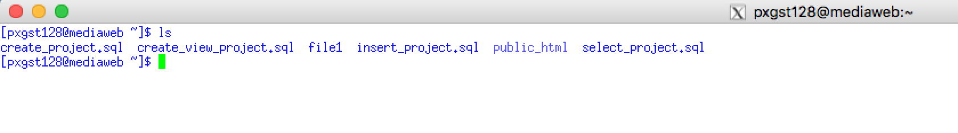

4.3.2 Type and execute the Linux command ***ls -l***

*After the ls command and every Linux you must provide one or spaces. After the Linux command you may specify command options which begin with a hyphen (-) A command option provides the opportunity to alter or customize a Linux command. This command option is -l, a lower-case letter L*

**Using a snipping tool** **document your results below. Make sure your Putty banner is displayed.**

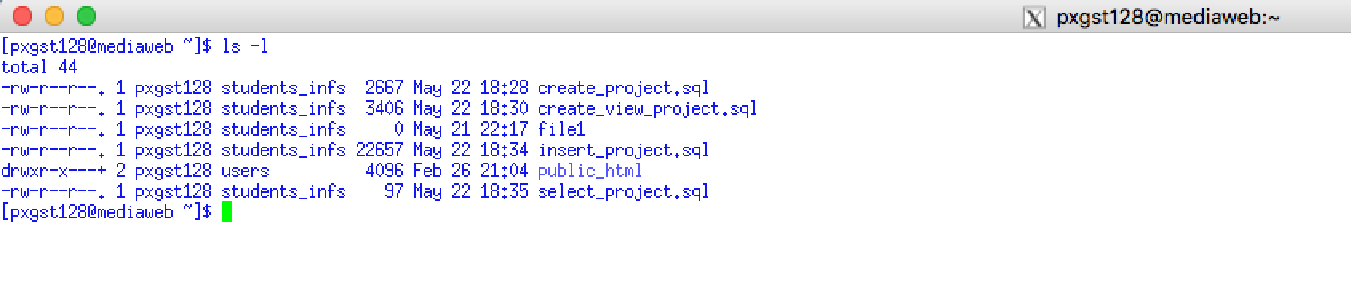

The **ls -l** Linux./Unix command is useful find detailed information about your scripts. Not only do we forget the name of the script, we also forget to copy the updated script to the academics server. Compare the date and time of the scripts on your computer to that you copied to mediaweb.rmu.edu. Sometimes a student makes a change to a SQL script on their personal computer and will forget to upload the updated script.

4.3.3 Clear the Linux screen. Type **clear** and press the enter key to execute the Linux command.

Type and execute the Linux command ***cat create_project.sql***

**Using a snipping tool** **document your results below. Make sure your Putty banner is displayed.**

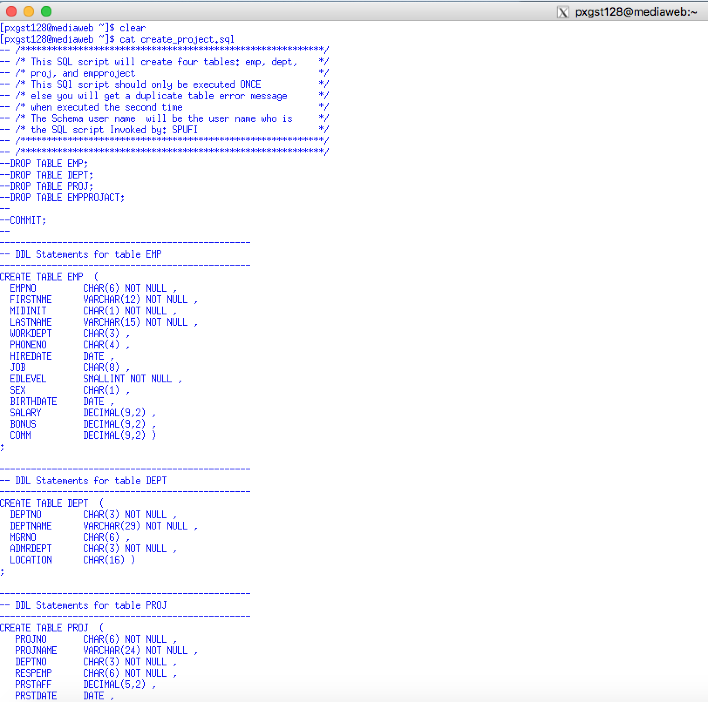

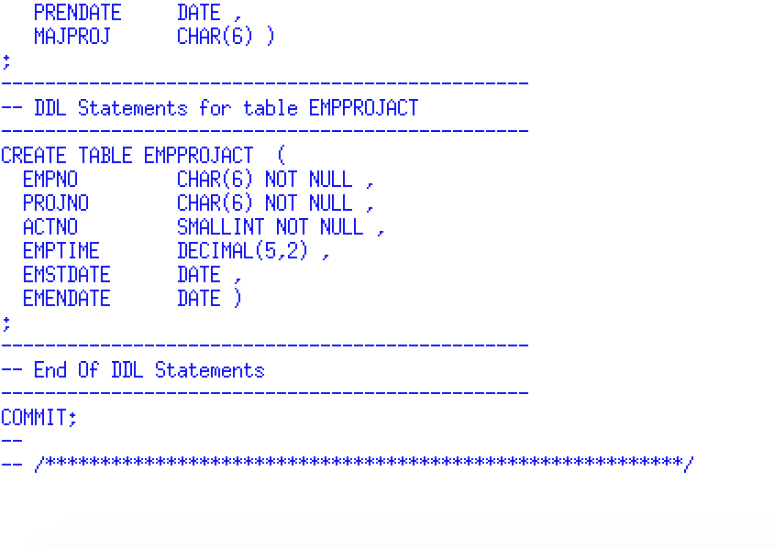

The Linux cat command to display the contents of your script. You then can compare the contents of the SQL script of your personal computer with the SQL stored on the server.

**All Linux/Unix commands are to be written in lower-case letters. Linux commands and scripts are case-sensitive. Oracle does not care about case.**

# 5.0 SQLPlus and Oracle Authentication and Authoization

## 5.1. Use the sqlplus Linux command

At the Linux command prompt type the sqlplus command followed by at least one space, your assigned Oracle ID followed by and @InstanceName. For example, the general format of the Oracle Logon string is OracleID@InstanceName

**The main functions of the Linux sqlplus command is to authenticate to the Oracle security system and to provide a command line interface, or command shell, to execute SL*Plus and SQL commands.**

An instance name is the arbitrary name assigned to the Oracle resources assigned to your course and section number. For example, my example would be valid for INFS6240 Section A. You instance may be different. Consult your instructor if you are having any problems



**Database versus instances**

An Oracle Database is a collection of physical operating system files or disks.

An Oracle Instance is a set of Oracle background processes or threads and a shared memory area, which is memory that is shared across those threads/processes running on a single computer. This the place to maintain volatile, nonpersistent stuff (some of which gets flushed to disk).

The two terms are sometimes used interchangeably, but they embrace very different concepts. The relationship between them is that a database may be mounted and opened by many instances. An instance may mount and open a single database at any point in time. In fact, it is true to say that an instance will mount and open at most a single database in its entire lifetime! A database instance can exist without any disk storage whatsoever.

**You logon to Linux or Window's operating system to be authenticated or to access a file or folder. Likewise, you logon to an Oracle instance to be authenticated or to access a database file.**

## 5.2. Review your INFS6240 email for sqlplus and Oracle Logon details

A sample section of the RMU IT INFS6240 emailed to you is displayed below. It provides all of the details you need, **including the exact format of the sqlplus command that you will need to logon on Oracle.**

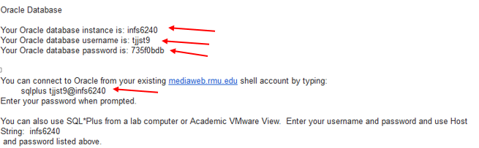

## 5.3 Enter to Oracle password provided to you in the email sent to you.

The directions for changing your password after a successful Oracle Logon will be provided shortly. If you forget your password either the RMU help desk can assist you or your instructor can. You are only provided three password attempts. You may attempt to reconnect to SQLPLus since there is no password attempt lockout in force.

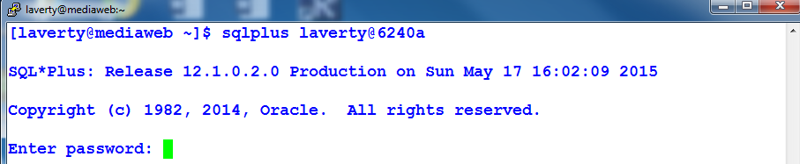

### 5.3.1 Linux versus Oracle Authentication

So now you may be confused. Why do I need an Oracle password, but the Linux server required SSH Key authentication? Oracle is a subsystem or middleware which executes under an operating system. An Oracle DBA may choose to a different Oracle authentication method than the host operating system. In fact, in this course you may access Oracle without using Linux by using Oracle's SQL Developer.

Later in the course, you will learn about Oracle Authentication. Oracle, like Linux, many accept multiple authentication policies including SSH authentication. Many IT organizations use the Linux/Oracle authentication model will set a policy that if Linux (the host operating system) has accepted your authentication, then Oracle will accept your Oracle user id without authentication.

### 5.3.2 Linux versus Oracle Authorizations

The security concept of authorization specifies the permissions, what an authenticated user or group may perform. For example, Linux file and directory permissions specify the rules for storing files under control of the Linux operating system, but Linux file and directory permissions may have no effect of an Oracle user or group to create, access or modify data in a Oracle data base or table. Likewise, an Oracle user or group may have the permission to create, access or modify data in an Oracle data base or table, but has no file permission to store or modify files under the control of the Linux file system.

### 5.3.3 SQL code development and Linux Authorization

When you use Oracle's SQL Developer your SQL coding work may be stored locally on your personal computer. In the professional world SQL code is more frequently stored on servers, not the local client, where operating system security can be enforced, SQL code can be shared by developer teams or DBAs, SQL code and be automatically backup, and SQL code can be tested by independent quality control standards.

More importantly, all Oracle professionals are extremely familiar with command line Linux and SQL*Plus, but will use to opportunity to use GUI tools their coding productivity.

## 5.4 The SQL> Command Prompt

### 5.4.1 You MAY execute SQL statements or SQL*Plus commands at the SQL> prompt

After a successful Oracle logon SQL*Plus displays the SQL*Plus command prompt: SQL>

The **SQL>** command prompt indicates that SQL*Plus is ready to accept your SQL statement or SQLPlus commands, not Linux commands.

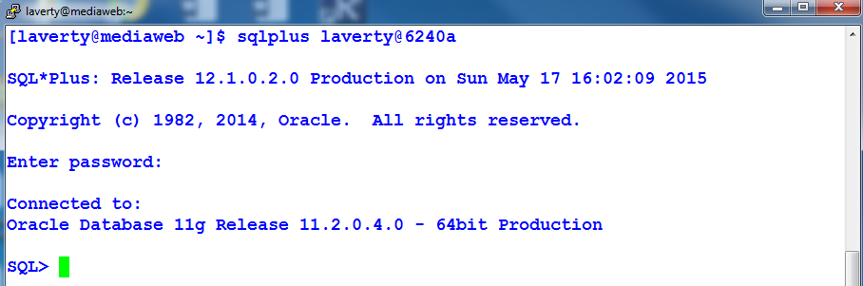

**Review the appearance of the Linux command prompt.**



### 5.4.2 You may NOT directly enter Linux Commands at the SQL> prompt

**ALWAYS, ALWAYS CHECK THE COMMAND PROMPT**

If you attempt to enter a Linux command at the SQL> prompt, e.g., the Linux ls command, SQLPlus will give you an error message.



### 5.4.3 SQL*Plus Error Prefixes

***Error message starting with SP2- is a SQLPLUS error message.***

SQL*Plus Error Messages - https://docs.oracle.com/cd/B19306_01/server.102/b14357/ch13.htm#i1044321

***Error messages starting with ORA- is an Oracle SQL syntax error.***

Search for ORA- Error Messages - <http://www.oracle.com/pls/db92/db92.error_search?prefill=ORA->

### 5.4.4 Executing Linux commands at The SQL> prompt

You may execute a Linux command at the SQL> prompt by prefixing the Linux command with an Exclamation point. For example:

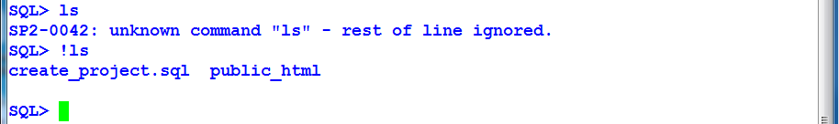

At the SQL> command prompt type and execute the command ***!ls***

**Using a snipping tool** **document your results below.**

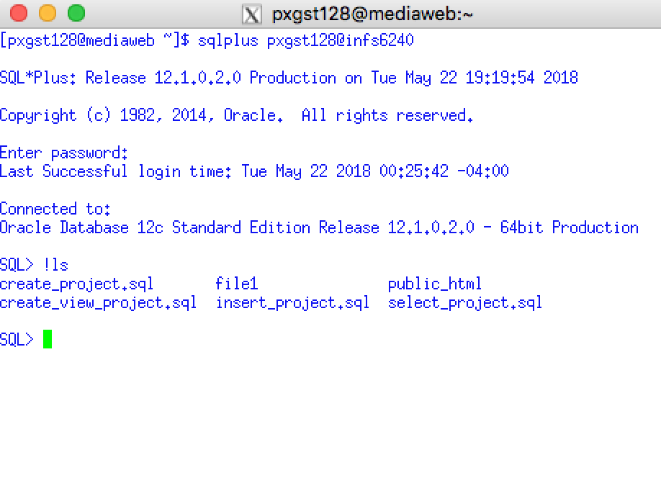

### 5.4.5 SQL*Plus clear screen command

As stated previously I must see your top Putty Banner line to receive credit for this assignment. I recommend the use of the Linux clear command. The Linux clear command will not work since the SQL*Plus command has a different purpose. However, enter the SQL*Plus command **clear screen** at the SQL> command prompt



At the SQL> command prompt type and execute the command ***!ls***

**Using a snipping tool** **document your results below. Make sure your Putty banner is displayed.**

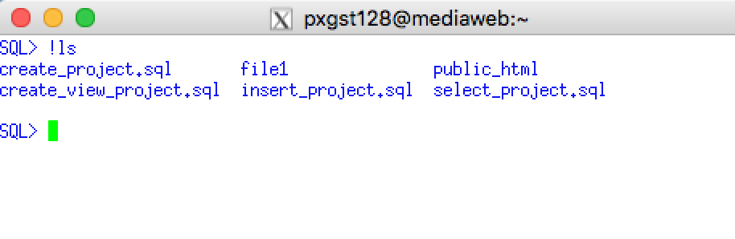

To display the contents of the script using the Linux command cat

At the SQL command prompt type and execute the command

***!cat create_project.sql***

**Be careful typing the underscore character.**

**Using a snipping tool** **document your results below. Make sure your Putty banner is displayed.**

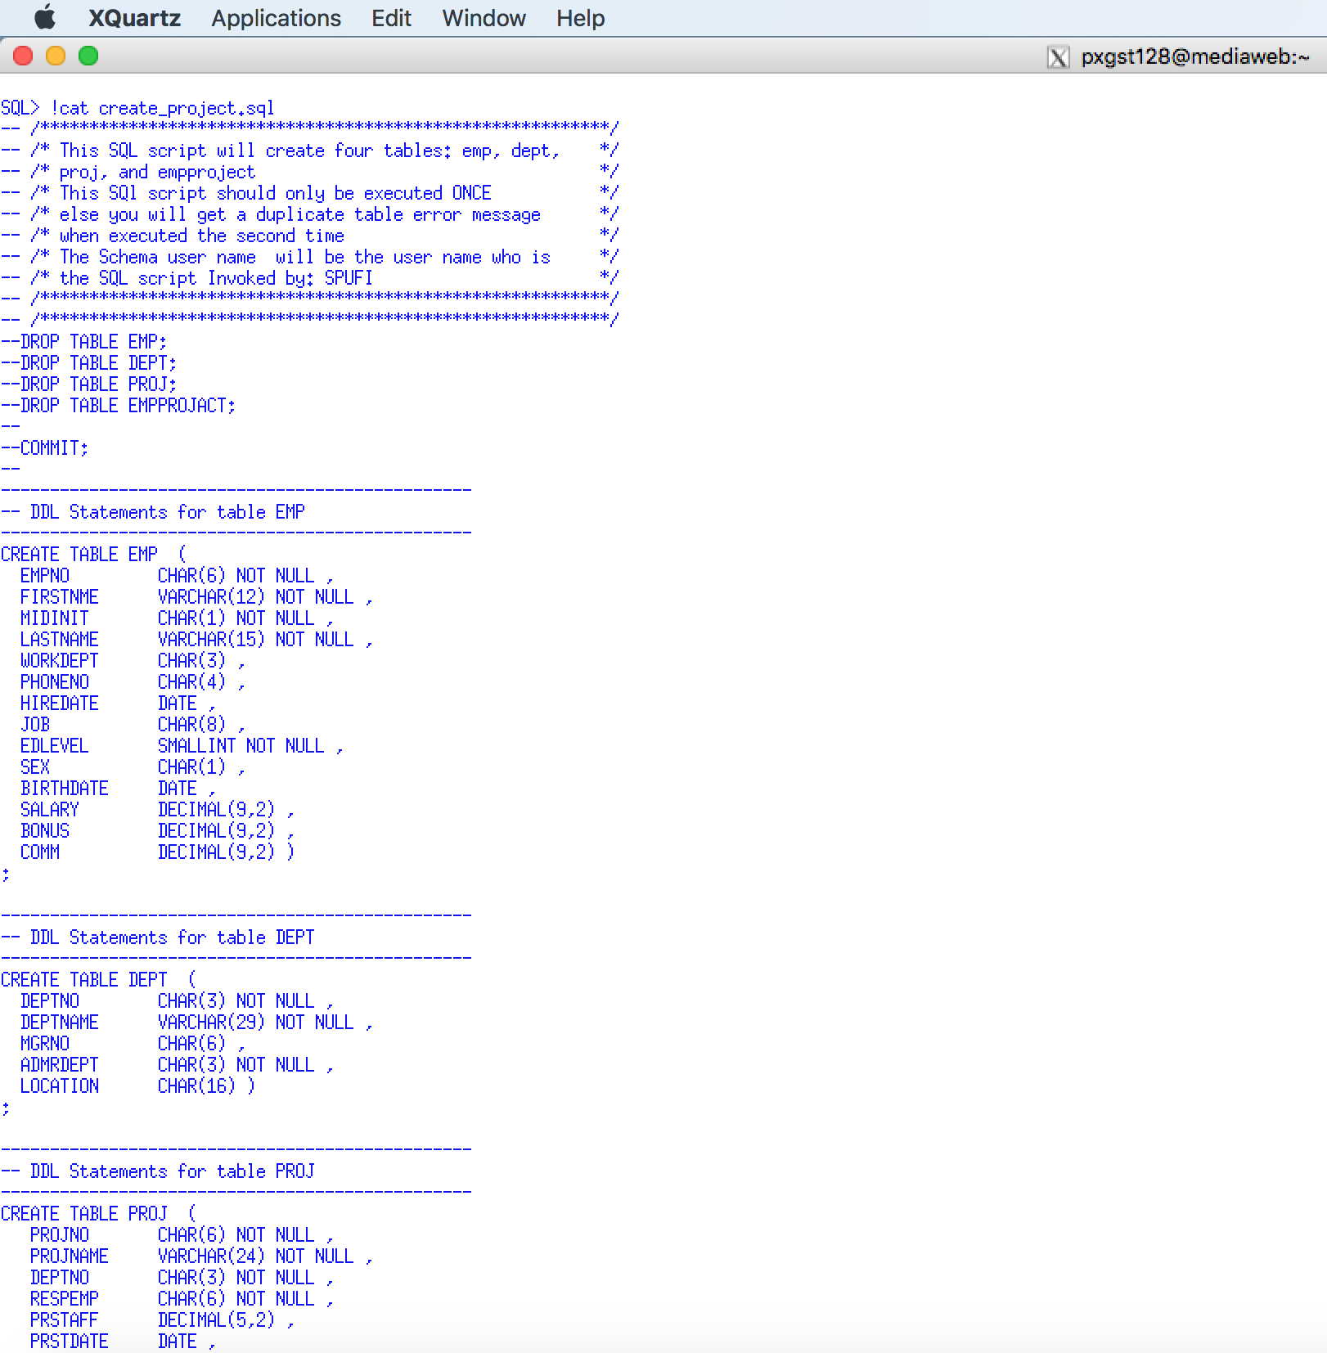

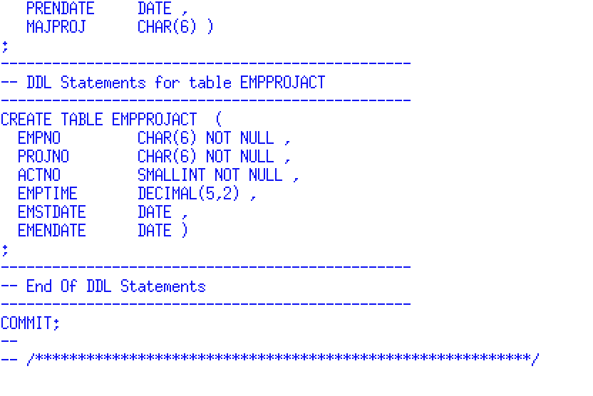

# 6.0 Executing SQL Script Files

## 6.1 SQL*Plus @ (at symbol)

Now it is time to execute the three SQL script files that you previously uploaded using WinSCP

Prefix the name of the SQL script file with an **@** symbol followed by the Linux file name. By default, the SQL script file must be located in the current Linux directory that was used when you started SQL*Plus. However, you may specify and absolute or relative file path name. For example:

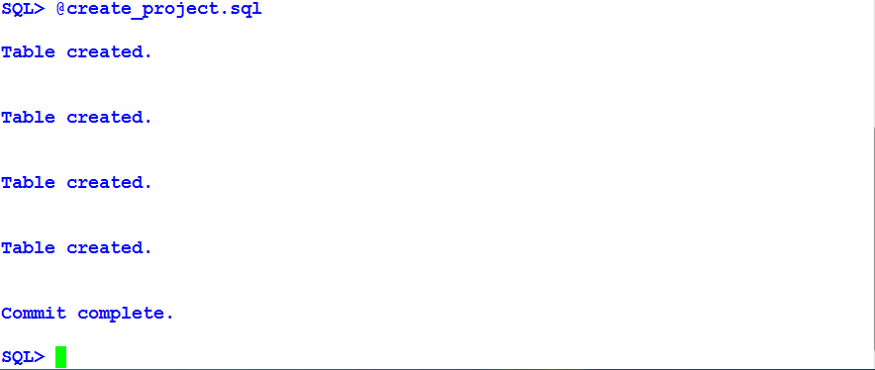

## 6.2 SQL Script files

An SQL script file is any text file which contains one or more SQL statements, stored in host operating system, and is normally executed in the batch processing mode by a data base professional, with limited interaction to the user. Oracle provides a similar concept called a PL/SQL Stored Procedure. A stored procedure may contains on or more SQL statements but is stored in Oracle, not the local operating system.

SQL scripts are often used to support customized administrative, reporting or security processing. SQL scripts are frequently used to initialize a database for new application, such as, an inventory control program, ERP system, or social media database. This requirement will require you to initialize a simple project management database so that you may learn simple SQL statements.

## 6.3 Execute and Document your Project Management Database

1. At the SQL> command prompt type and execute the command

***@create_project.sql***

**Be careful typing the underscore character.**

**Using a snipping tool** **document your results below. Make sure your Putty banner is displayed.**

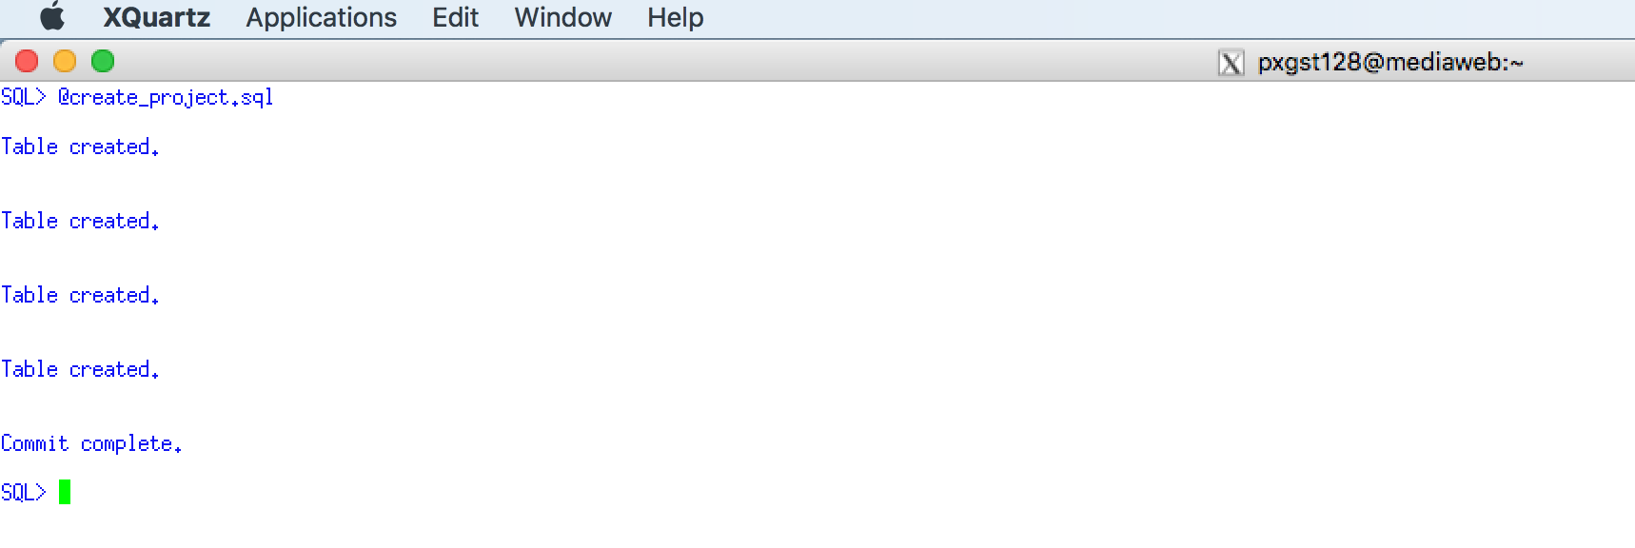

2. At the SQL> command prompt type and execute the command

***@insert_project.sql***

**Be careful typing the underscore character.**

**Using a snipping tool** **document your results below. Make sure your Putty banner is displayed.**

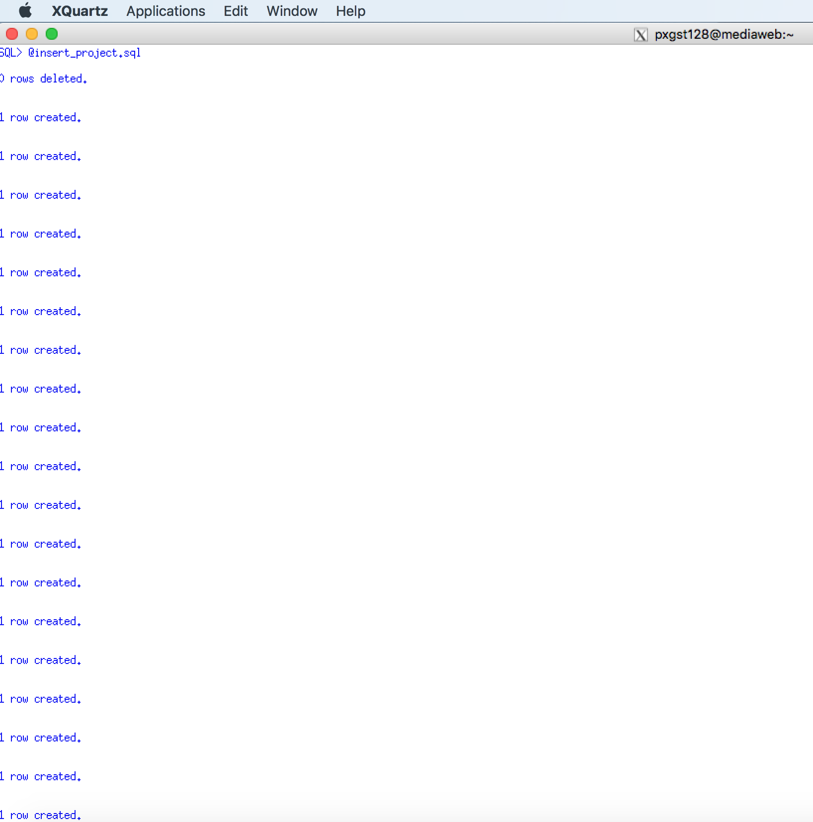

3. At the SQL> command prompt type and execute the command

***@select_project.sql***

**Be careful typing the underscore character.**

**Using a snipping tool** **document your results below. Make sure your Putty banner is displayed.**

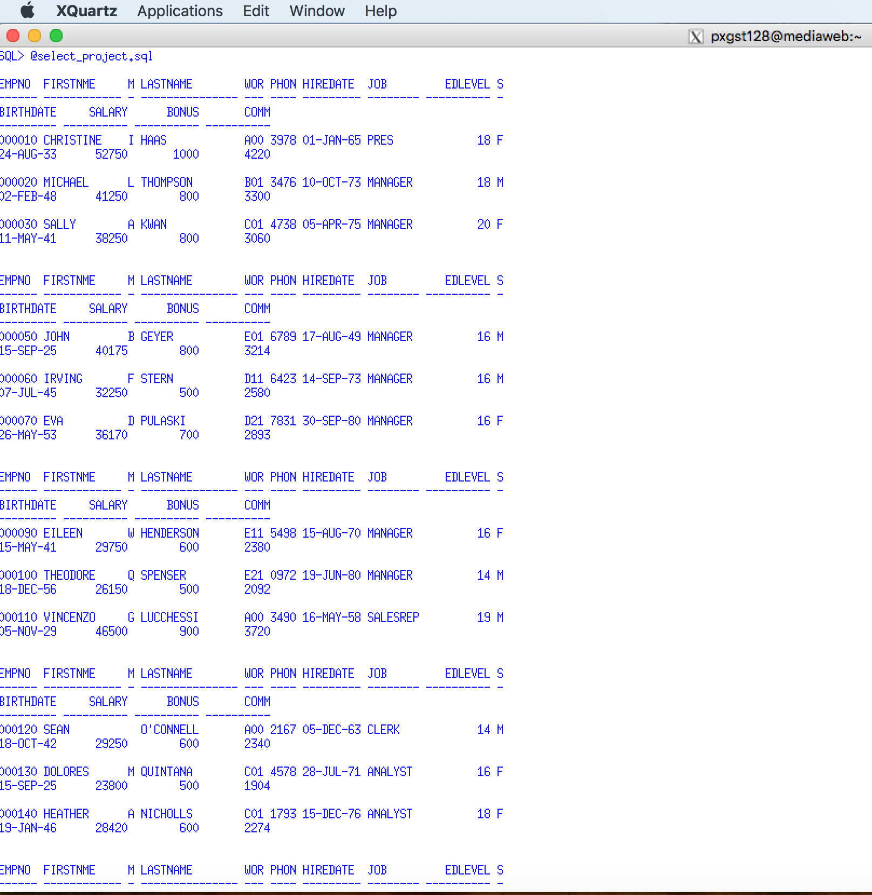

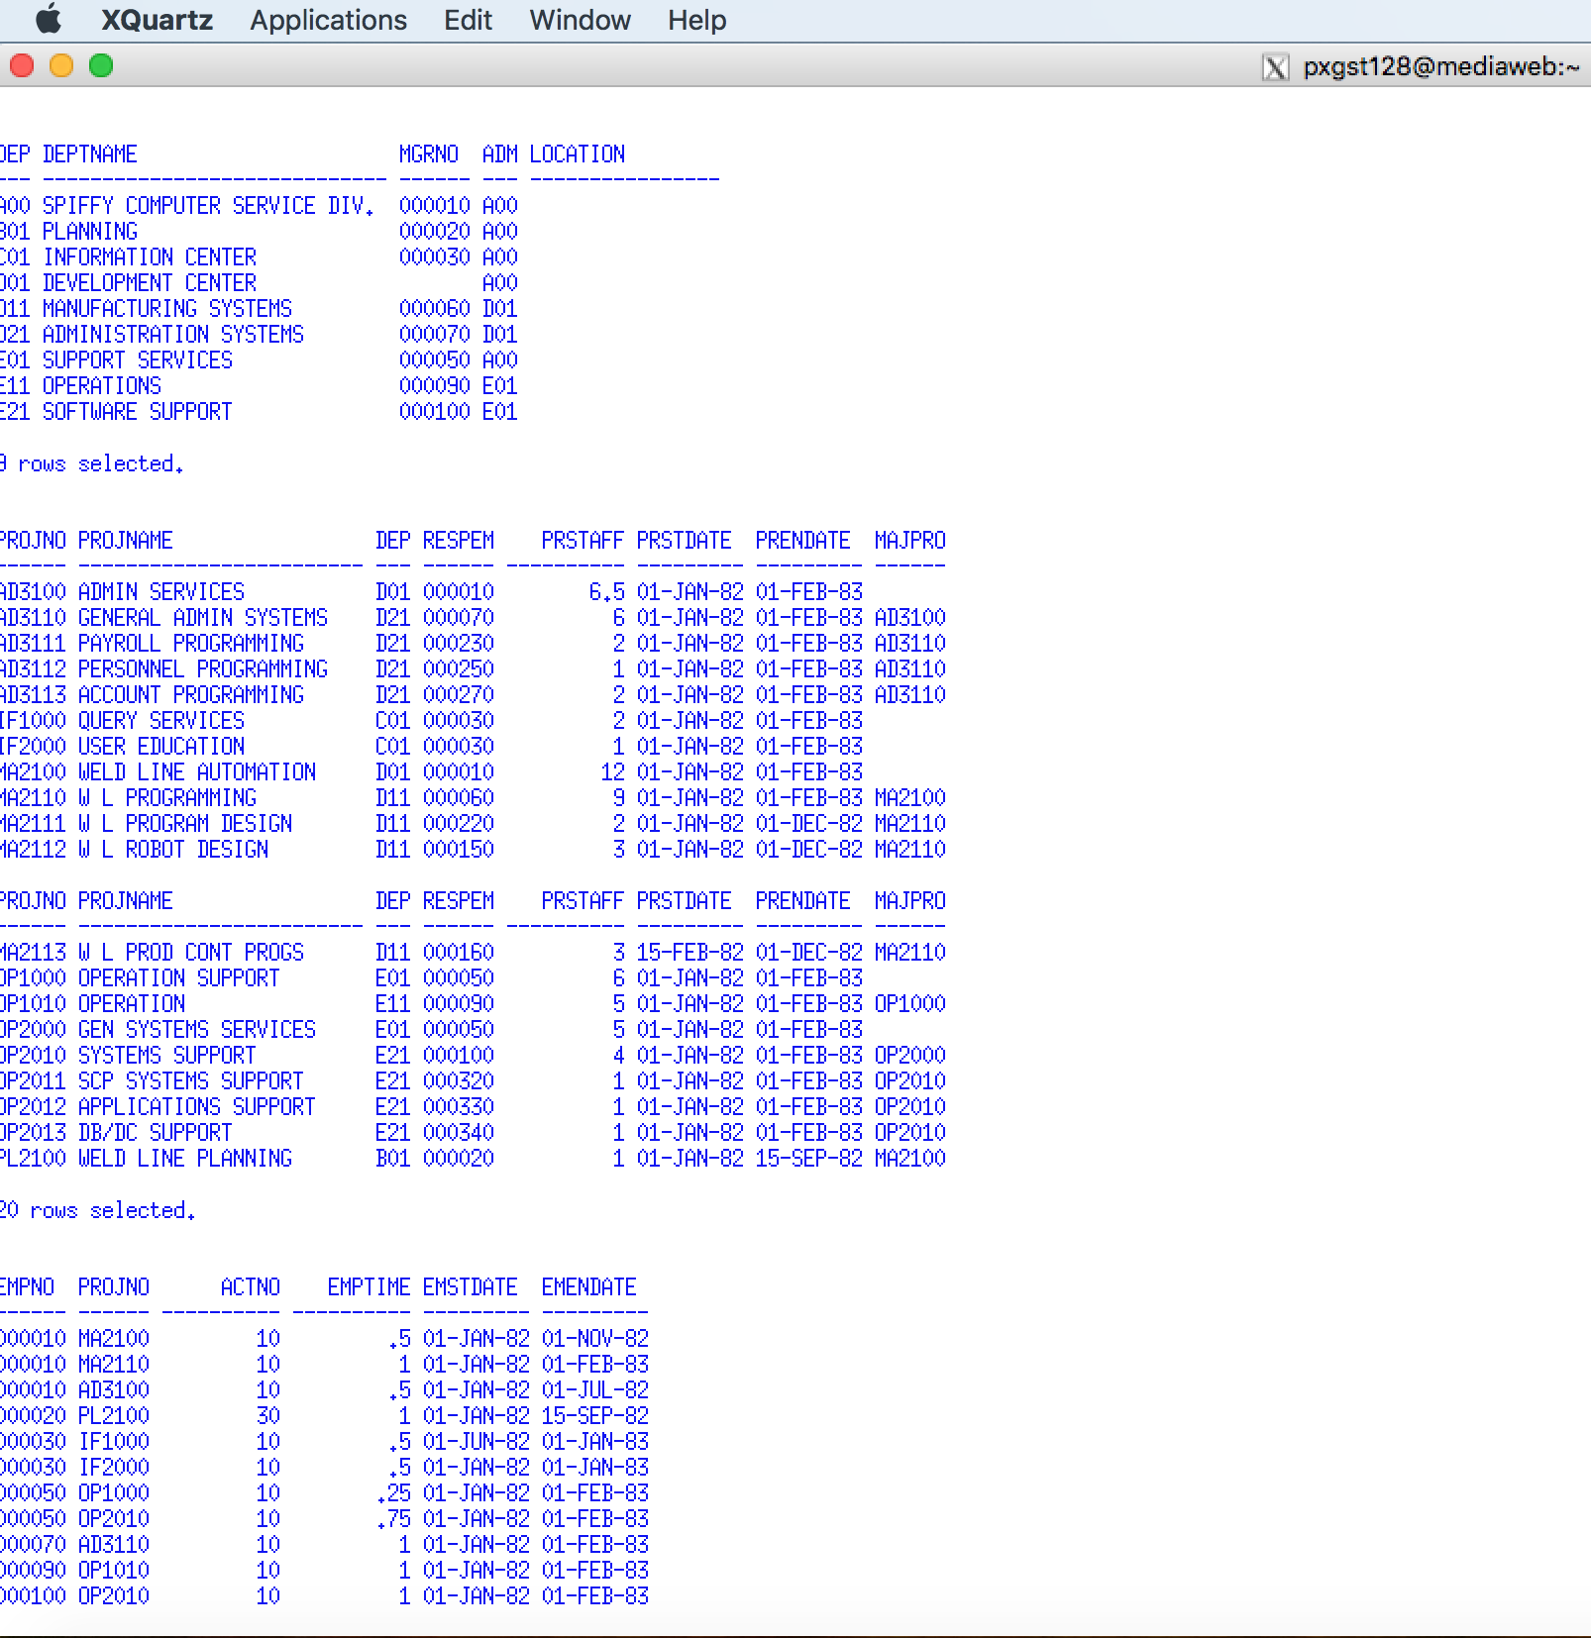

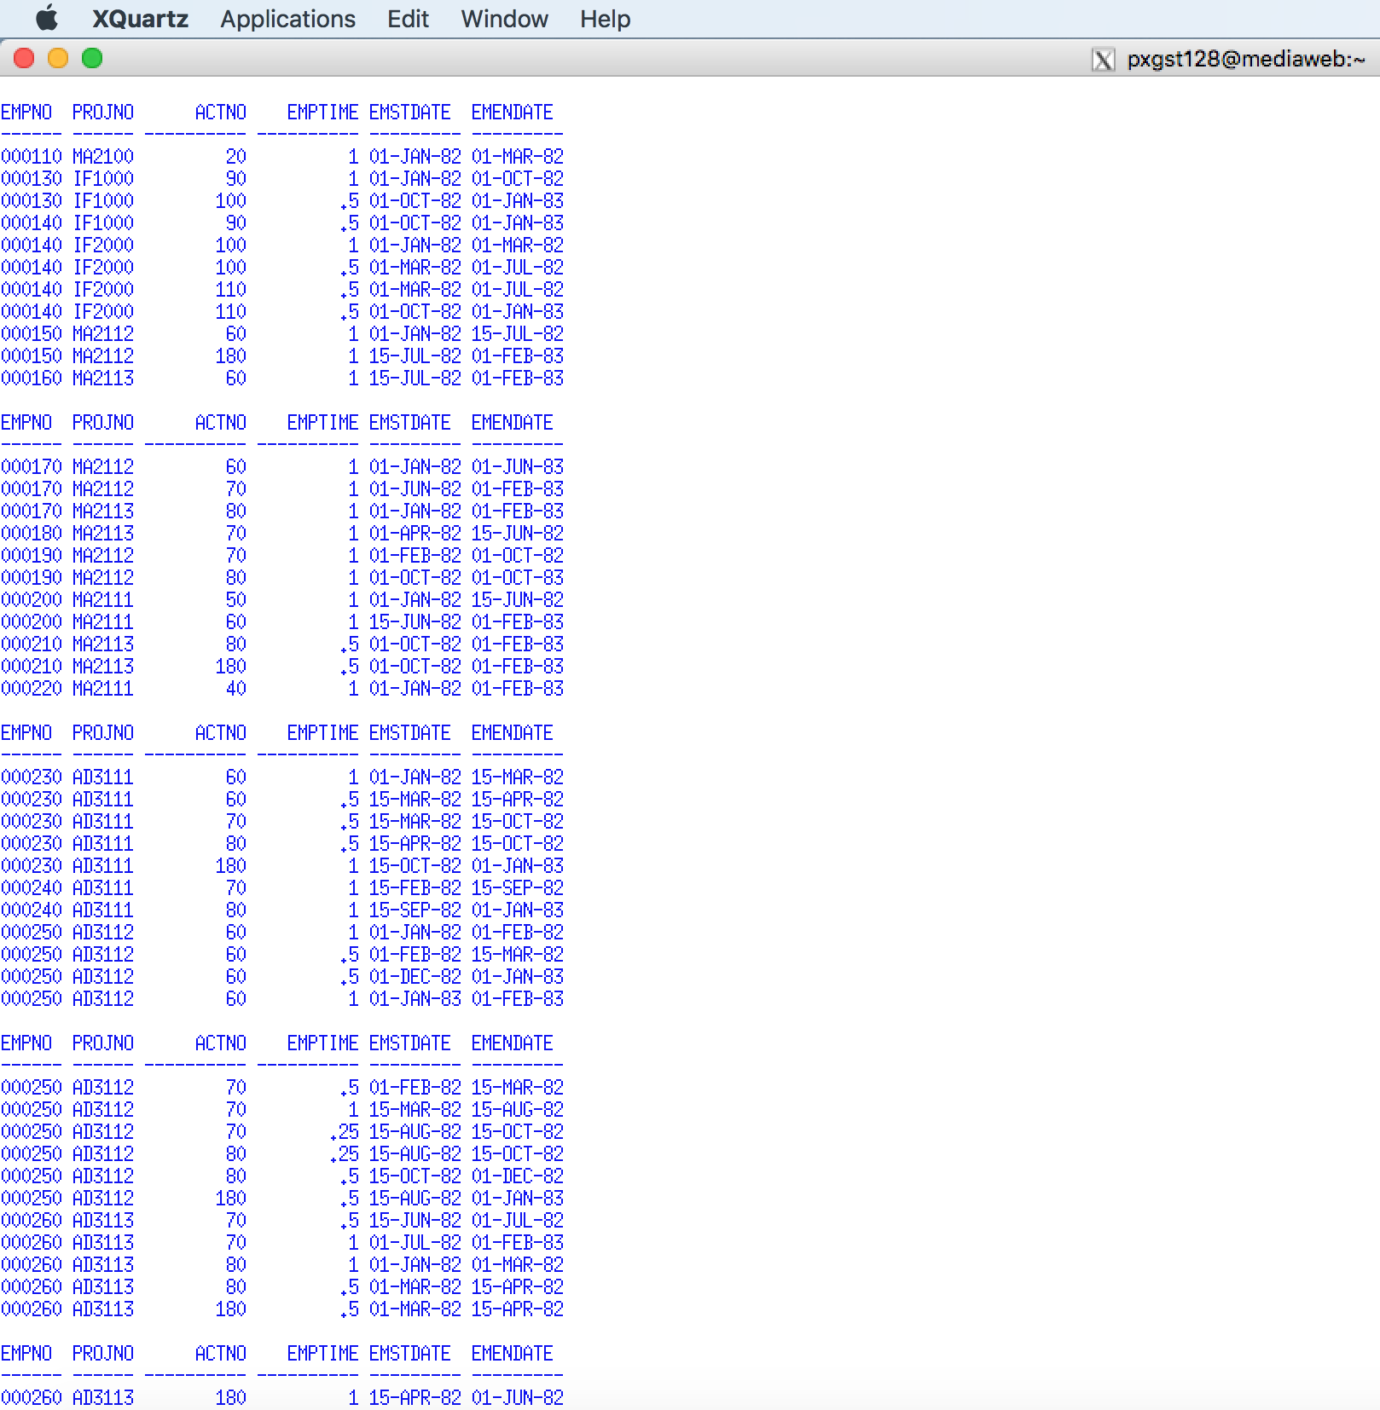

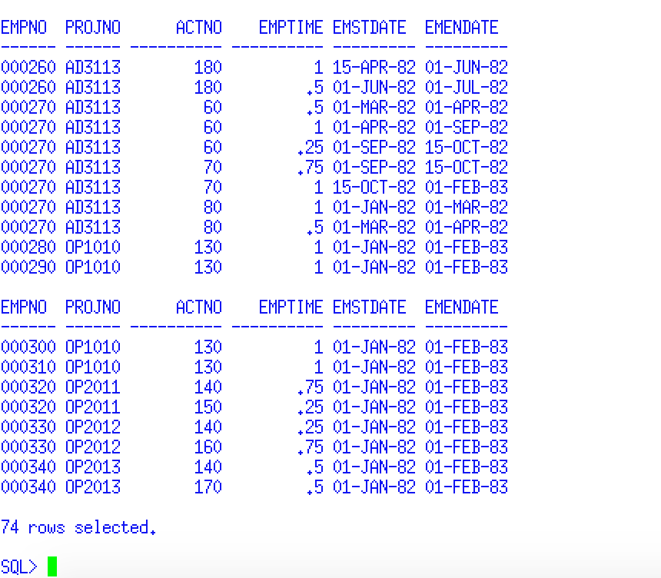

4. At the SQL> command prompt type and execute the command

***@create_view_project.sql***

**Be careful typing the underscore character.**

**Using a snipping tool** **document your results below. Make sure your Putty banner is displayed.**

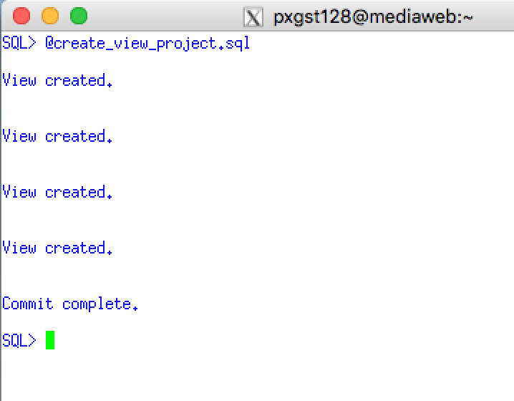

## 6.4 Document using user_all_tables.

To provide documentation that all four tables were successfully created, the following requirement will use the Oracle catalog and the administration view **user_all_tables**. **All SQL commands must end with a semicolon.** Linux and SQLPlus commands (which you will learn later) do not end with a semicolon. The semicolon informs SQLPlus that you are finished coding the SQL statement submit it for execution

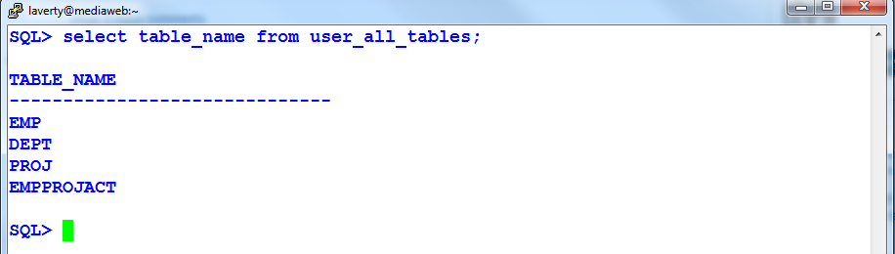

**Forgetting the training semicolon**

Students frequently forget to type the ending semicolon and SQL*Plus with display a second line and will do nothing.



Type the missing semicolon on the second line and press the Enter Key to execute.

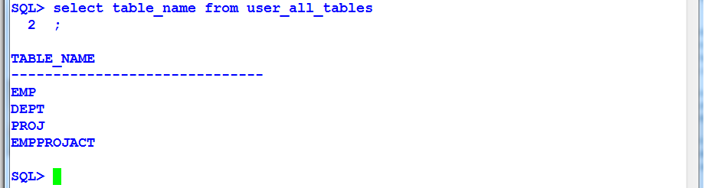

If you make a typing error or use incorrect syntax, SQL*Plus will display an ORA error and positions at an asterisk and at the approximate of the syntax error. The details of correcting Oracle syntax errors will be discussed in detail for future assignments.

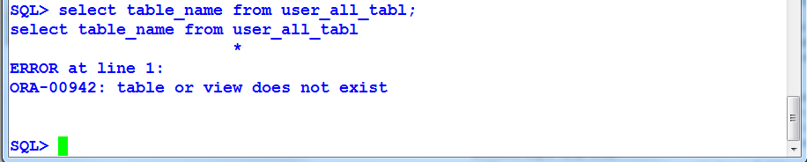

4. At the SQL command prompt type and execute the command

***select table_name from user_all_tables;***

Be careful typing the underscore character.

**Using a snipping tool** **document your results below. Make sure your Putty banner is displayed.**

## 6.5 Documenting your word using the DESCRIBE command

The SQL command Describe command will display the structure of individual tables. The details of the information provided by the describe command will be discussed in Assignment 3 when the CREATE TABLE command is presented. Since DESCRIBE is a SQL command it must mend with a semicolon .

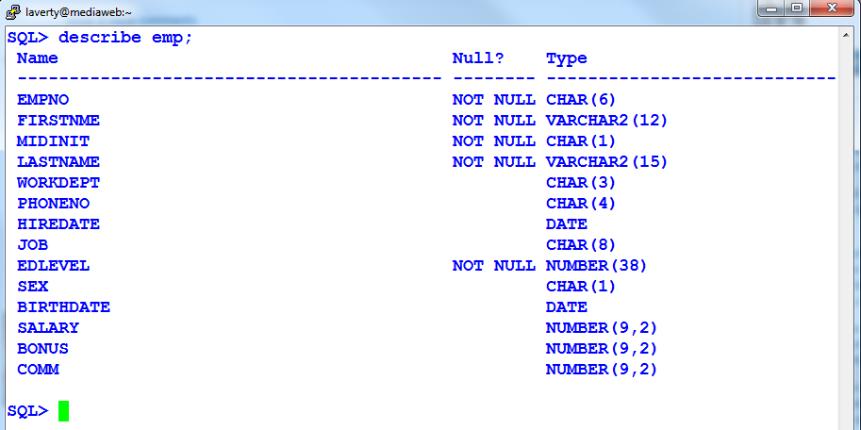

5. At the SQL command prompt type and execute the command

***describe emp;***

**Using a snipping tool** **document your results below. Make sure your Putty banner is displayed.**

6. At the SQL command prompt type and execute the command

***describe dept;***

**Using a snipping tool** **document your results below. Make sure your Putty banner is displayed.**

7. At the SQL command prompt type and execute the command

***describe proj;***

**Using a snipping tool** **document your results below. Make sure your Putty banner is displayed.**

8. At the SQL command prompt type and execute the command

***describe empprojact;***

**Using a snipping tool** **document your results below. Make sure your Putty banner is displayed.**

# 7.0 Exiting SQL*Plus and Linux

**To exit SQL*Plus and return to Linux**

At the SQL> prompt type **EXIT**

**To exit Linux and Putty**

At the Linux prompt type **EXIT**

# 8.0 Review Questions

1. What is the main functions of the Linux sqlplus command? Your answer is 🡺

**it is a command-line tool for accessing oracle database XE. Enables to enter and run SQL, PL/SQL, and SQL*plus commands.**

2. What are the differences between an Oracle instance and an Oracle database? Your answer is 🡺

**Oracle database is the set of files where application data and meta data is stored. An instance is the software that oracle uses to manipulate data in the database.**

3. Use a Windows or Linux operating system analogy explain the concept of an Oracle instance and database. Your answer is 🡺

.Fall 2017

4. Explain and contrast the differences between Linux and Oracle authentication. Your answer is 🡺

5. Explain and contrast the differences between Linux and Oracle authorization and acces to stored file or objects. Your answer is 🡺

6. At the SQL> command prompt, you encounter a SP2 error message. What is the cause of a SP2 error message? Your answer is 🡺

.Fall 2017

7. At the SQL> command prompt, you encounter an ORA error message. What is the cause of an ORA error message? Your answer is 🡺

8. How does one execute a Linux command at the SQL> command prompt? Your answer is 🡺

9. What is an SQL Script file? Your answer is 🡺

**SQL script is a set of SQL commands store in a file. It can contain one or more SQL statements.**

10. List three or more popular functions of SQL Script file. Your answer is 🡺

.Fall 2017

12. As used in this assignment, provide the most popular example of a SQL Script file. Your answer is 🡺

13. At the SQL> prompt, explain the procedure to execute a SQL script file. Your answer is 🡺

14. Explain one of the major differences between an SQL script file and a PL/SQL stored procedure. Your answer is 🡺

.Fall 2017

15. List two methods to document the structure of the Oracle tables. Your answer is 🡺

16. Which Linux command maybe used to erase the Putty window? Your answer is 🡺

17. Which SQL*Plus command maybe used to erase the Putty window? Your answer is 🡺

18. Which command is used to exit SQL*Plus and return to the Linux prompt? Your answer is 🡺

19. Which command is used to exit Linux? Your answer is 🡺

20. When documenting your hands-on requirements when using Putty, what snipping tool documentation must be provided to verify the student's your identity? Your answer is 🡺

.Fall 2017